Web Development 3.1

Sprint #1 Project (page 2-15)

Sprint #2 Project (page 16 – 34)

Natalia Palej

Software Design With Artificial Intelligence For Cloud Computing  
Year 3 Semester 1

Student ID: A00279259

Table of Contents

Sprint #1 2

User Stories 2

Database/Makeup User Stories 2

User User Stories 2

Testing 3

Database/Makeup Test Cases 3

User Test Cases 9

Test Report 12

Bugs Report 12

SPRINT #2 15

User Stories 15

Database/Makeup User Stories 15

User User Stories 15

Testing 16

Database/Makeup Test Cases 16

User Test Cases 21

Test Report 32

Bugs Report 32

References 33

Screencast Link 33

# Sprint #1

## User Stories

### Database/Makeup User Stories

1. As a Makeup CEO, I want to connect server and database, so that I can access my inventory.
2. As a Makeup CEO, I want to read data in JSON format for all makeup products, so that I can use it in my application.
3. As a Makeup CEO, I want to search for products based on product name/company/category.
4. As a Makeup CEO, I want to insert new makeup product into database, so that I can expand on my inventory.
5. As a Makeup CEO, I want to update product details in database based on its ID, so that I can keep accurate information.
6. As a Makeup CEO, I want to delete product from database based on its ID, so that I can remove discontinued products.

### User User Stories

1. **As a User, I want to log in, so that I can have access to the account.** **[[ PART 2 ]]**
2. **As a User, I want to log out, so that my account stays secure. [[ PART 2 ]]**
3. As a User, I want to create new user, so that I can have more clients.
4. As a User, I want to delete existing user, so that I can remove inactive clients.
5. As a User, I want to update existing user details, so that I can keep accurate details.
6. As a User, I want to read users’ details, so that I can use it in my application.
7. As a User, I want to read user details based on their ID, so that I can get their details.

## Testing

### Database/Makeup Test Cases

**PRE-REQUISITES:**

Before conducting each test, it is assumed the below conditions are met:

1. Application server and database is running.
2. Postman REST Client is opened.

When executing each test, it is assumed that:

1. User will enter appropriate request (GET/PUT/DELETE/POST)
2. After inputting the command, user presses “enter/send”.

#### Test #1

|  |  |
| --- | --- |
| User Story | Get API connection |
| Test Case ID | #1 |
| Description | Verify valid URL |
| Given | 1. Application server and database is running 2. Postman REST Client Opened |
| When | 1. Set GET request 2. Enter URL http://localhost/Assessment/Sprint1 3. Press send |
| Then | HTTP response 200 OK |
| Test Result | Passed Failed |

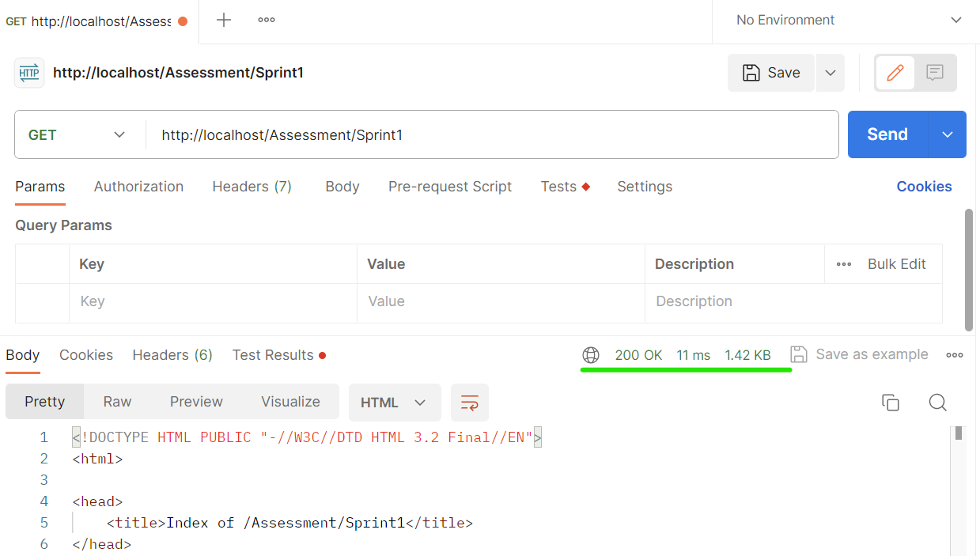

#### Test #2

|  |  |
| --- | --- |
| User Story | Get API connection |
| Test Case ID | #2 |
| Description | Verify invalid URL |
| When | Enter URL http://localhost:/Assessment/MyCompany |
| Then | HTTP response 404 NOT FOUND |
| Test Result | Passed Failed |

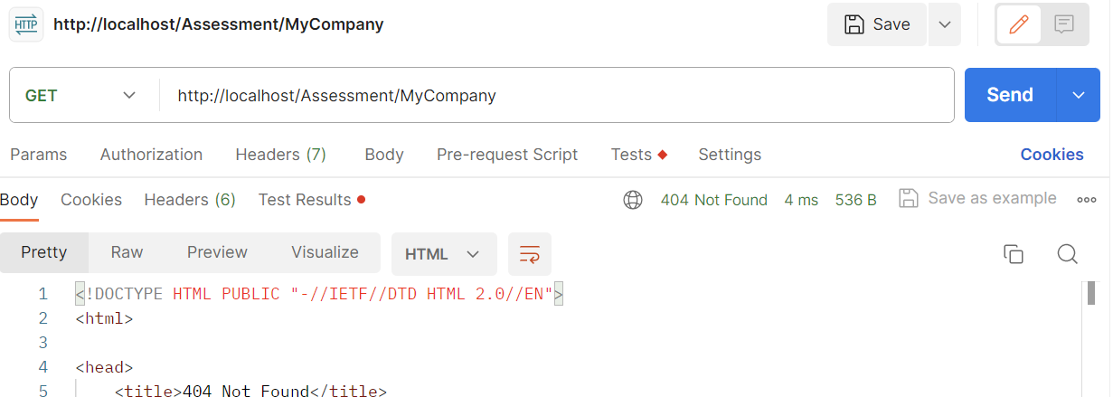

#### Test #3

|  |  |
| --- | --- |
| User Story | Read data in JSON format for all makeup products |
| Test Case ID | #3 |
| Description | Verify all products are retrieved |
| When | API URI: http://localhost/Assessment/Sprint1/api/makeup |
| Then | Makeup inventory is displayed |
| Test Result | Passed Failed |

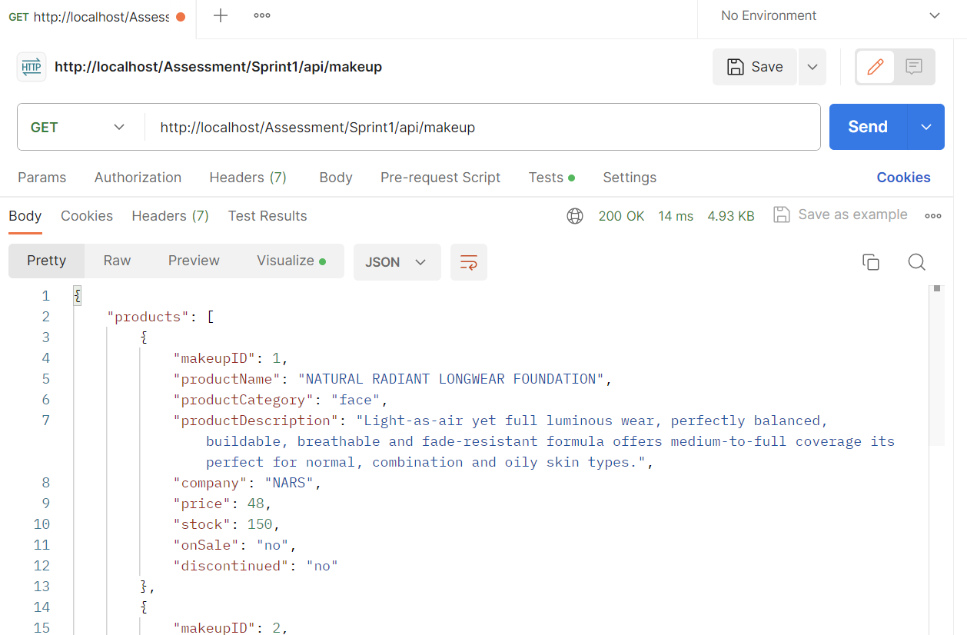

#### Test #4

|  |  |
| --- | --- |
| User Story | Search for product based on product name |
| Test Case ID | #4 |
| Description | Verify one product is retrieved |
| When | http://localhost/Assessment/Sprint1/api/makeup/skin |
| Then | Makeup product information displayed |
| Test Result | Passed Failed |

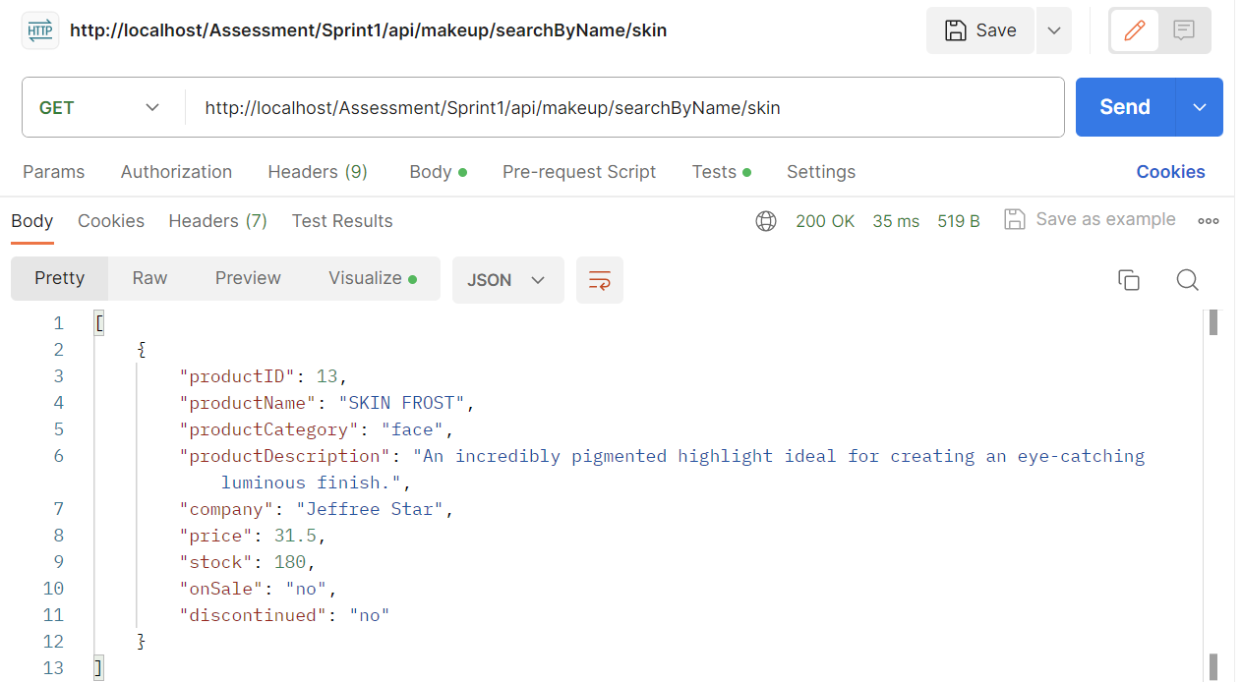

#### Test #5

|  |  |
| --- | --- |
| User Story | Search for product based on product name |
| Test Case ID | #5 |
| Description | Verify error displayed if product doesn’t exist |
| When | http://localhost/Assessment/Sprint1/api/makeup/search/byName/skon |
| Then | Error message displayed |
| Test Result | Passed Failed |

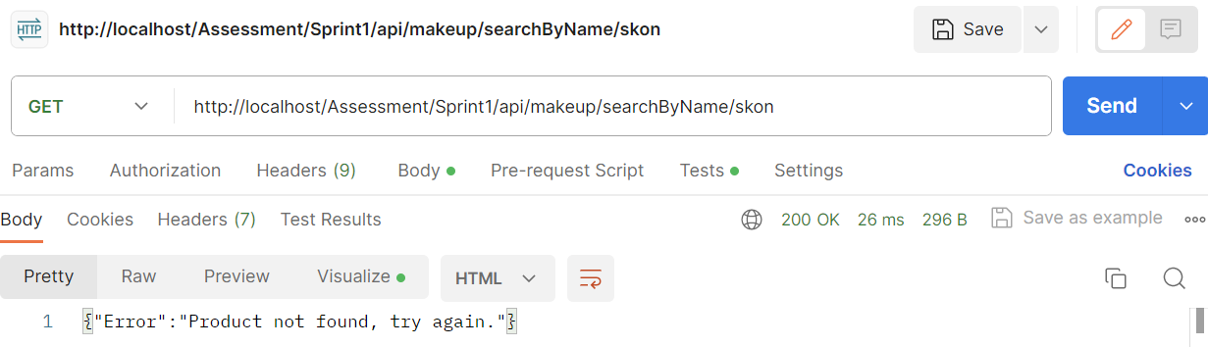

#### Test #6

|  |  |
| --- | --- |
| User Story | Search for product based on company |
| Test Case ID | #6 |
| Description | Verify product(s) are displayed |
| When | http://localhost/Assessment/Sprint1/api/makeup/search/byCompany/benefit |
| Then | List of products where company = Benefit is retrieved |
| Test Result | Passed Failed |

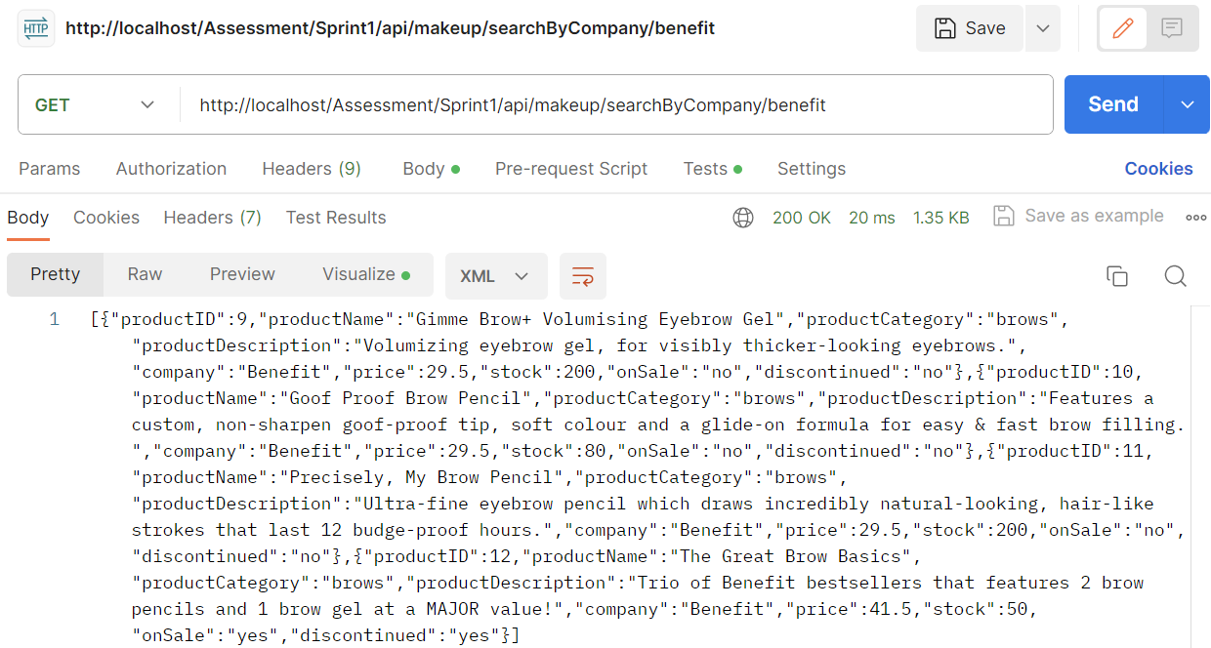

#### Test #7

|  |  |
| --- | --- |
| User Story | Search for product based on category |
| Test Case ID | #7 |
| Description | Verify product(s) are displayed |
| When | http://localhost/Assessment/Sprint1/api/makeup/search/ByCategory/eyes |
| Then | List of products where productCategory = eyes is retrieved |
| Test Result | Passed Failed |

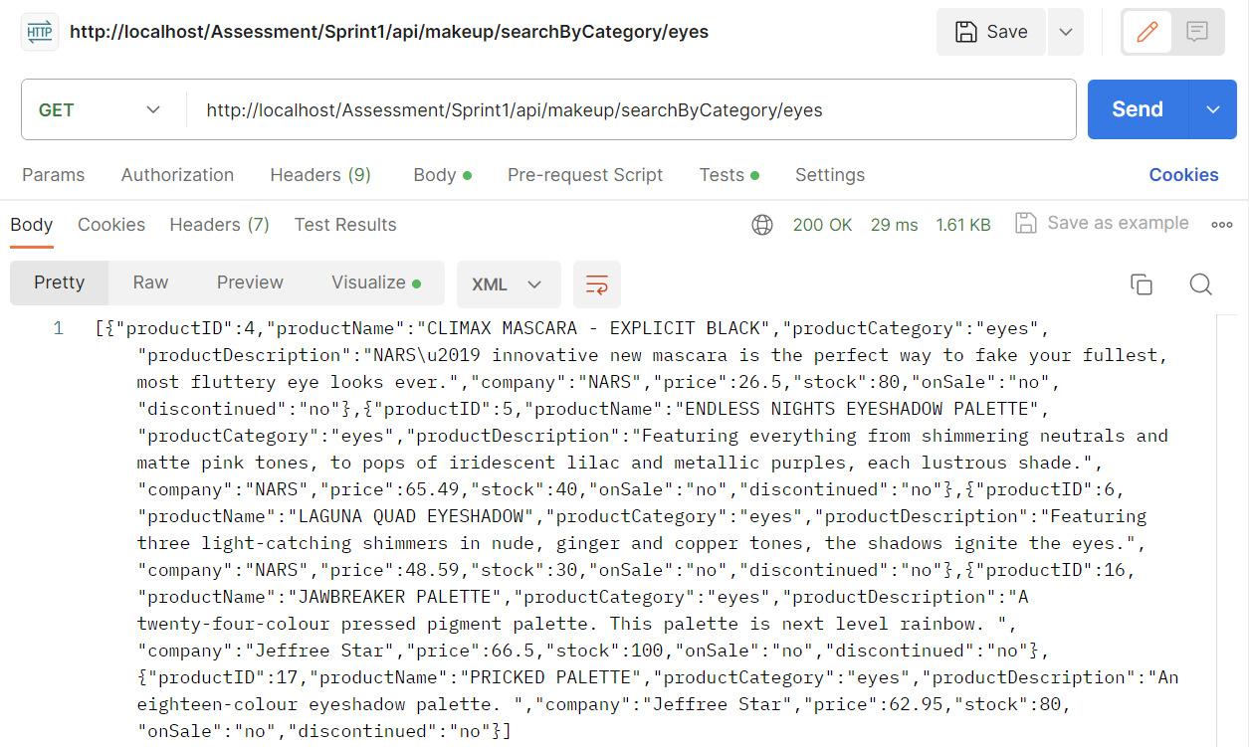

#### Test #8

|  |  |
| --- | --- |
| User Story | Insert new makeup product into database |
| Test Case ID | #8 |
| Description | Verify new product can be added |
| When | API URI: http://localhost/Assessment/Sprint1/api/makeup  {  "productName": "NUDE LIQUID LIPSTICK VAULT",  "productCategory": "lips",  "productDescription": "A 25-piece mini lipstick vault. For all the nudes you could possibly need.",  "company": "Jeffree Star",  "price": 173.25,  "stock": 50,  "onSale": "no",  "discontinued": "no"  } |
| Then | Product successfully added to makeupInventory |
| Test Result | Passed Failed |

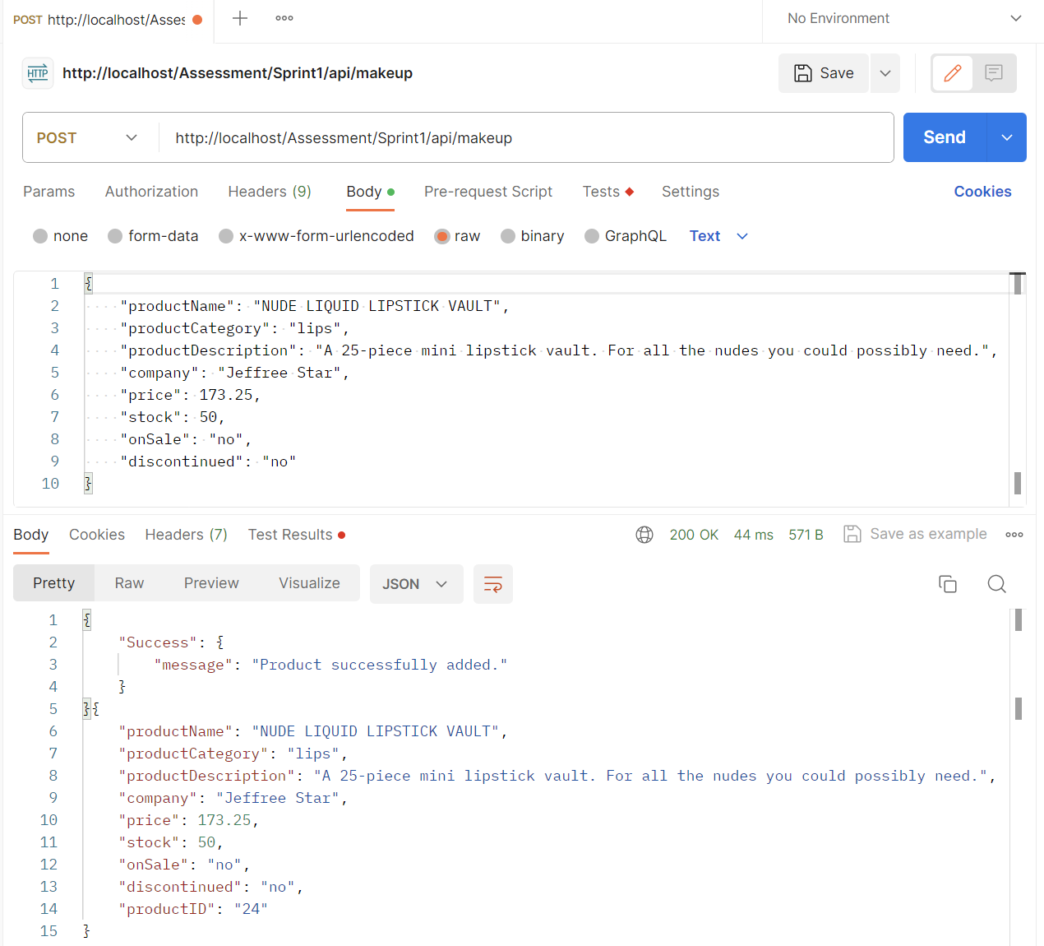

#### Test #9

|  |  |
| --- | --- |
| User Story | Update product details in database based on its ID |
| Test Case ID | #9 |
| Description | Verify product was successfully updated |
| When | API URI: <http://localhost/Assessment/Sprint1/api/makeup/5>  Update from “price”:”58.99” to “price”:”60.00” |
| Then | productID =5 price successfully updated |
| Test Result | Passed Failed |

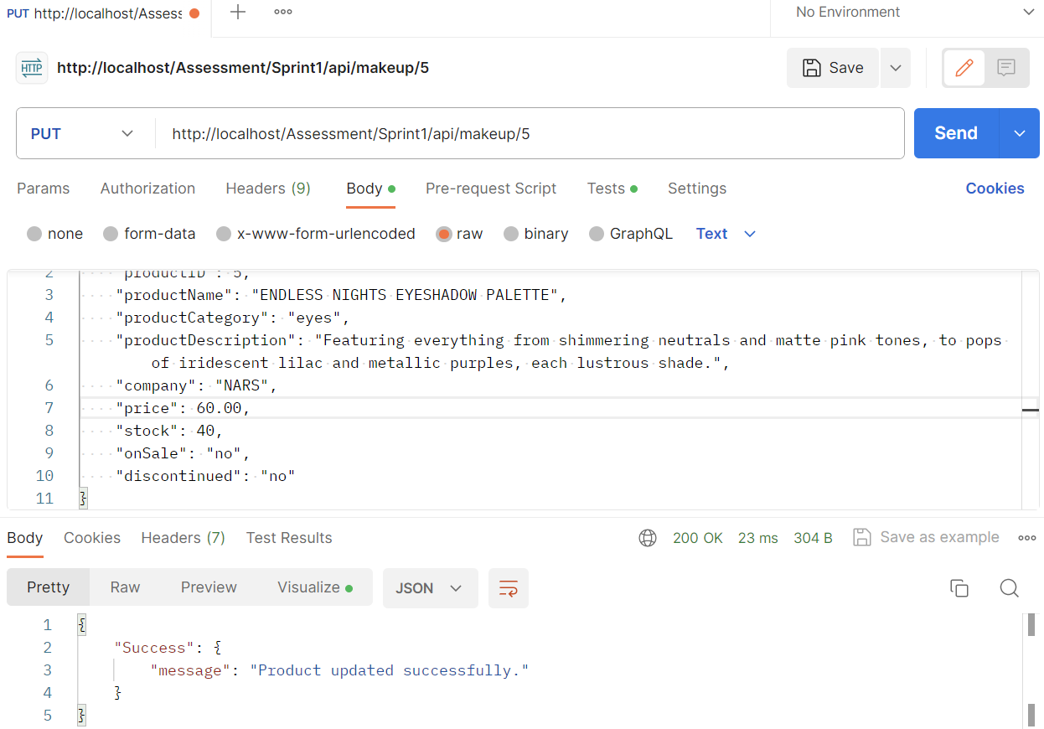

#### Test #10

|  |  |
| --- | --- |
| User Story | Delete product from database based on its ID |
| Test Case ID | #10 |
| Description | Verify product was successfully deleted from database |
| When | API URI: http://localhost/Assessment/Sprint1/api/makeup/delete/24 |
| Then | Product with ID=24 was successfully deleted from database |
| Test Result | Passed Failed |

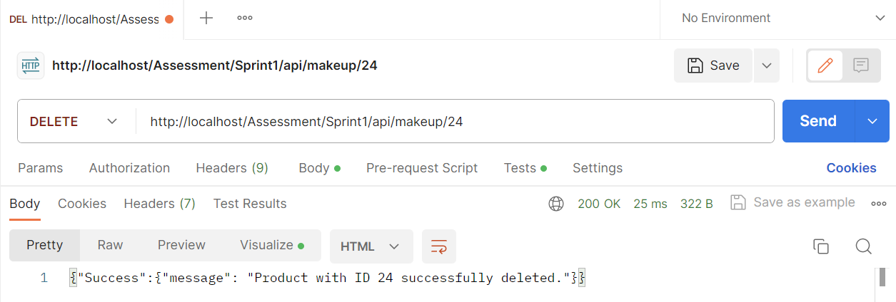

### User Test Cases

#### Test #1

|  |  |
| --- | --- |
| User Story | Read users details |
| Test Case ID | #1 |
| Description | Verify users’ details are retrieved |
| When | API URI: http://localhost/Assessment/Sprint1/api/users |
| Then | All users are displayed |
| Test Result | Passed Failed |

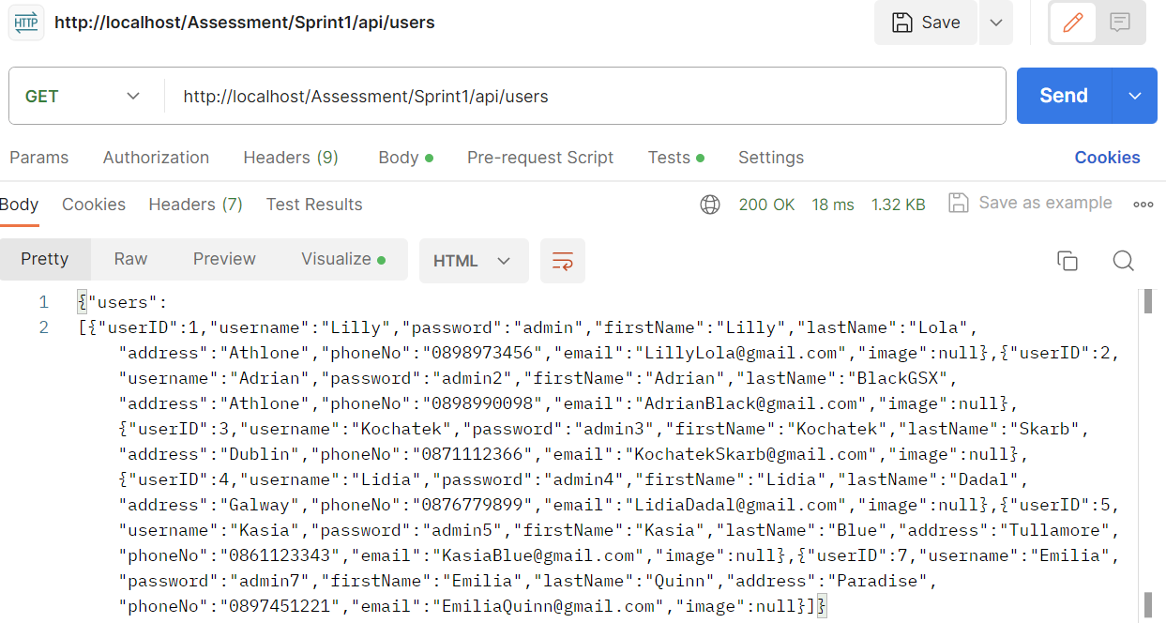

#### Test #2

|  |  |
| --- | --- |
| User Story | Read user data based on their ID |
| Test Case ID | #2 |
| Description | Verify userID=4 details are retrieved |
| When | API URI: http://localhost/Assessment/Sprint1/api/users/4 |
| Then | userID=4 details are retrieved |
| Test Result | Passed Failed |

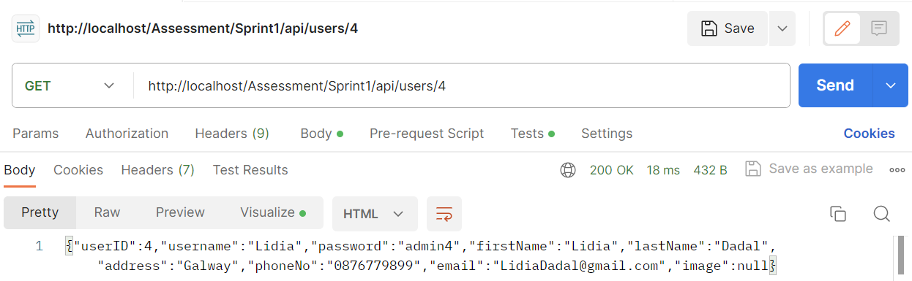

#### Test #3

|  |  |
| --- | --- |
| User Story | Update user data based on their ID |
| Test Case ID | #3 |
| Description | Verify userID=2 details are updated |
| When | API URI: <http://localhost/Assessment/Sprint1/api/users/2>  Update from “lastName”:”Black” to “lastName”:”BlackGSX” |
| Then | userID=2 successfully updated |
| Test Result | Passed Failed |

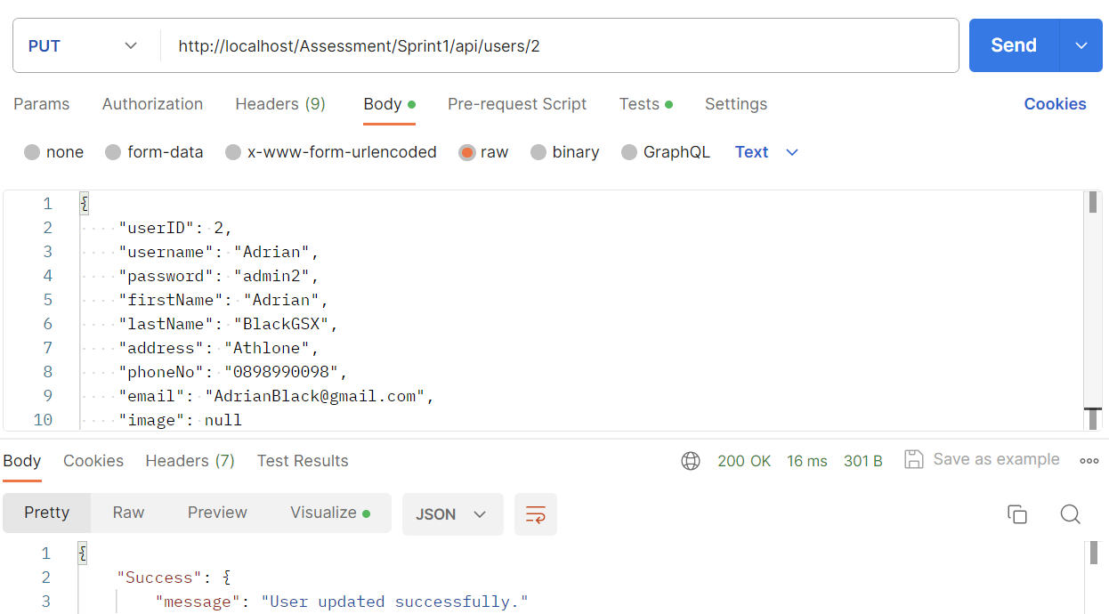

#### Test #4

|  |  |
| --- | --- |
| User Story | Delete user data based on their ID |
| Test Case ID | #4 |
| Description | Verify userID=6 has been deleted successfully |
| When | API URI : http://localhost/Assessment/Sprint1/api/users/6 |
| Then | userID=6 successfully deleted |
| Test Result | Passed Failed |

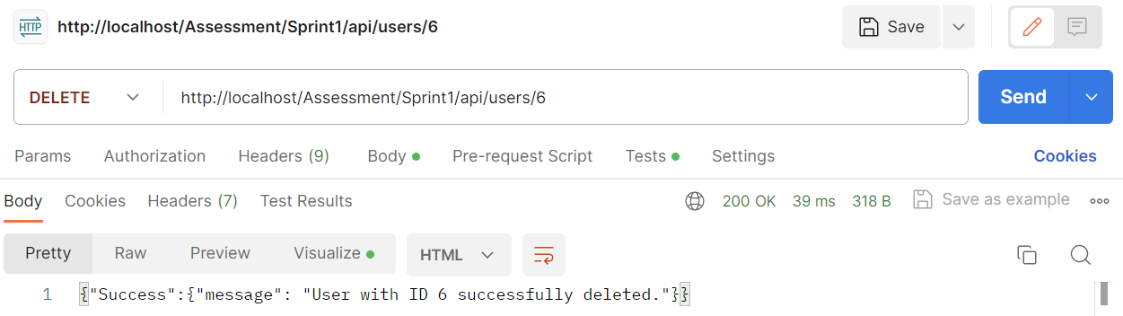

#### Test #5

|  |  |
| --- | --- |
| User Story | Create new user |
| Test Case ID | #5 |
| Description | Verify new user can be added to database |
| When | API URI: <http://localhost/Assessment/Sprint1/api/users>  {  "username": "Emilia",  "password": "admin7",  "firstName": "Emilia",  "lastName": "Quinn",  "address": "Paradise",  "phoneNo": "0897451221",  "email": "EmiliaQuinn@gmail.com",  "image": null  } |
| Then | userID=4 details are retrieved |
| Test Result | Passed Failed |

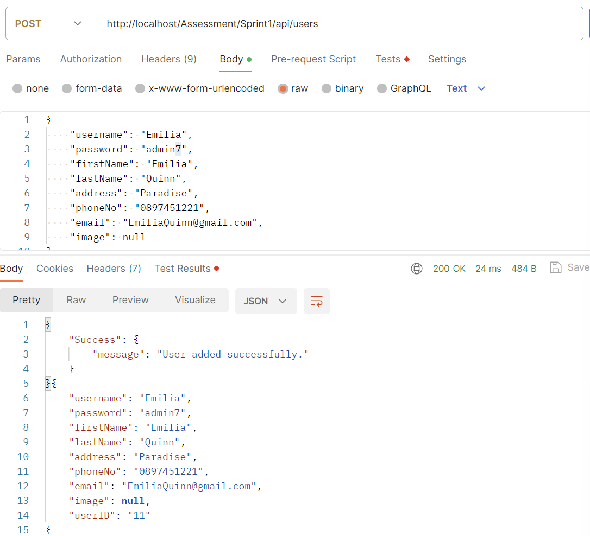

### Test Report

|  |  |  |  |  |
| --- | --- | --- | --- | --- |
| **Test Type** | **Database** | **Total Tests** | **Number Passed** | **Number Failed** |
| Manual | products | 10 | 10 | 0 |
| users | 5 | 5 | 0 |

### Bugs Report

#### Bug #1 : FIXED

|  |
| --- |
| Bug Description |
|  |
| Resolution |
| In my code I have forgotten to add **‘%** before and after $productName |

#### Bug #2 : FIXED

|  |
| --- |
| Bug Description |
|  |
| Resolution |
| URL route was incorrect, I have added additional “**/**” at the end of the API.    I simplified the route and got rid of “makeupInventory”. Final route: |

#### Bug #3 : FIXED

|  |
| --- |
| Bug Description |
|  |
| Resolution |
| Instead of returning $makeup**i**nventory I had $makeup**I**nventory which was giving below error:  <div><strong>Message:</strong> Undefined variable $makeupInventory</div> |

#### Bug #4 : FIXED

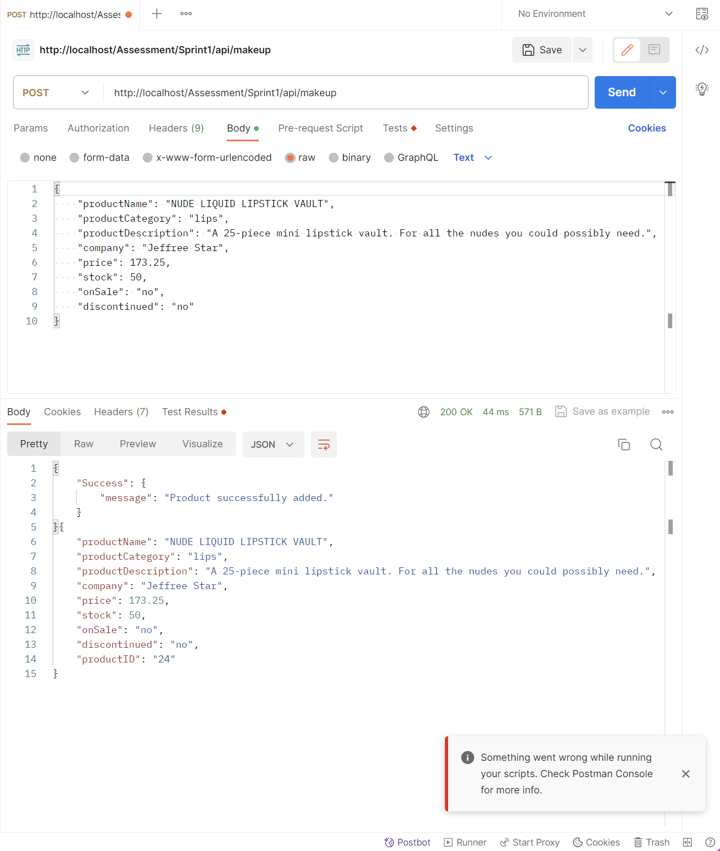

# SPRINT #2

## User Stories

### Database/Makeup User Stories

1. As a Makeup CEO, I want to connect server and database, so that I can access my inventory through local server.
2. As a Makeup CEO, I want to add product so I can have extra products in my store.
3. As a Makeup CEO, I want to update product info, so I can keep accurate information.
4. As a Makeup CEO, I want to delete product that I no longer stock.

### User User Stories

1. As a User, I want to log in, so that I can have access to the account.
2. As a User, I want to log out, so that my account stays secure.
3. As a User, I want to register, so I can create a new account.
4. As a User, I want to search through products, so I can decide which one to purchase.
5. As a User, I want to search for product by name/category/company, so that I can filter the result.
6. As a User, I want to be able to edit my details, so that I keep information up to date.
7. As a User, I want to be able to delete my account, so that I can no longer use the app.

## Testing

### Database/Makeup Test Cases

**PRE-REQUISITES:**

Before conducting each test, it is assumed the below conditions are met:

1. Database is up and running (xampp + workbench)
2. Web browser is opened.
3. URL entered is http://localhost/Assessment/Sprint2 /<html-file>

#### Test #1

|  |  |
| --- | --- |
| User Story | Get server connection |
| Test Case ID | #1 |
| Description | Verify valid URL |
| Given | 1. Database is running (xampp + workbench) 2. Valid API route was entered |
| When | 1. Double-click on .html file 2. Ensure route is <http://localhost/Assessment/Sprint2/login.html> 3. Press enter |
| Then | HTML page loads up |
| Test Result | Passed Failed |

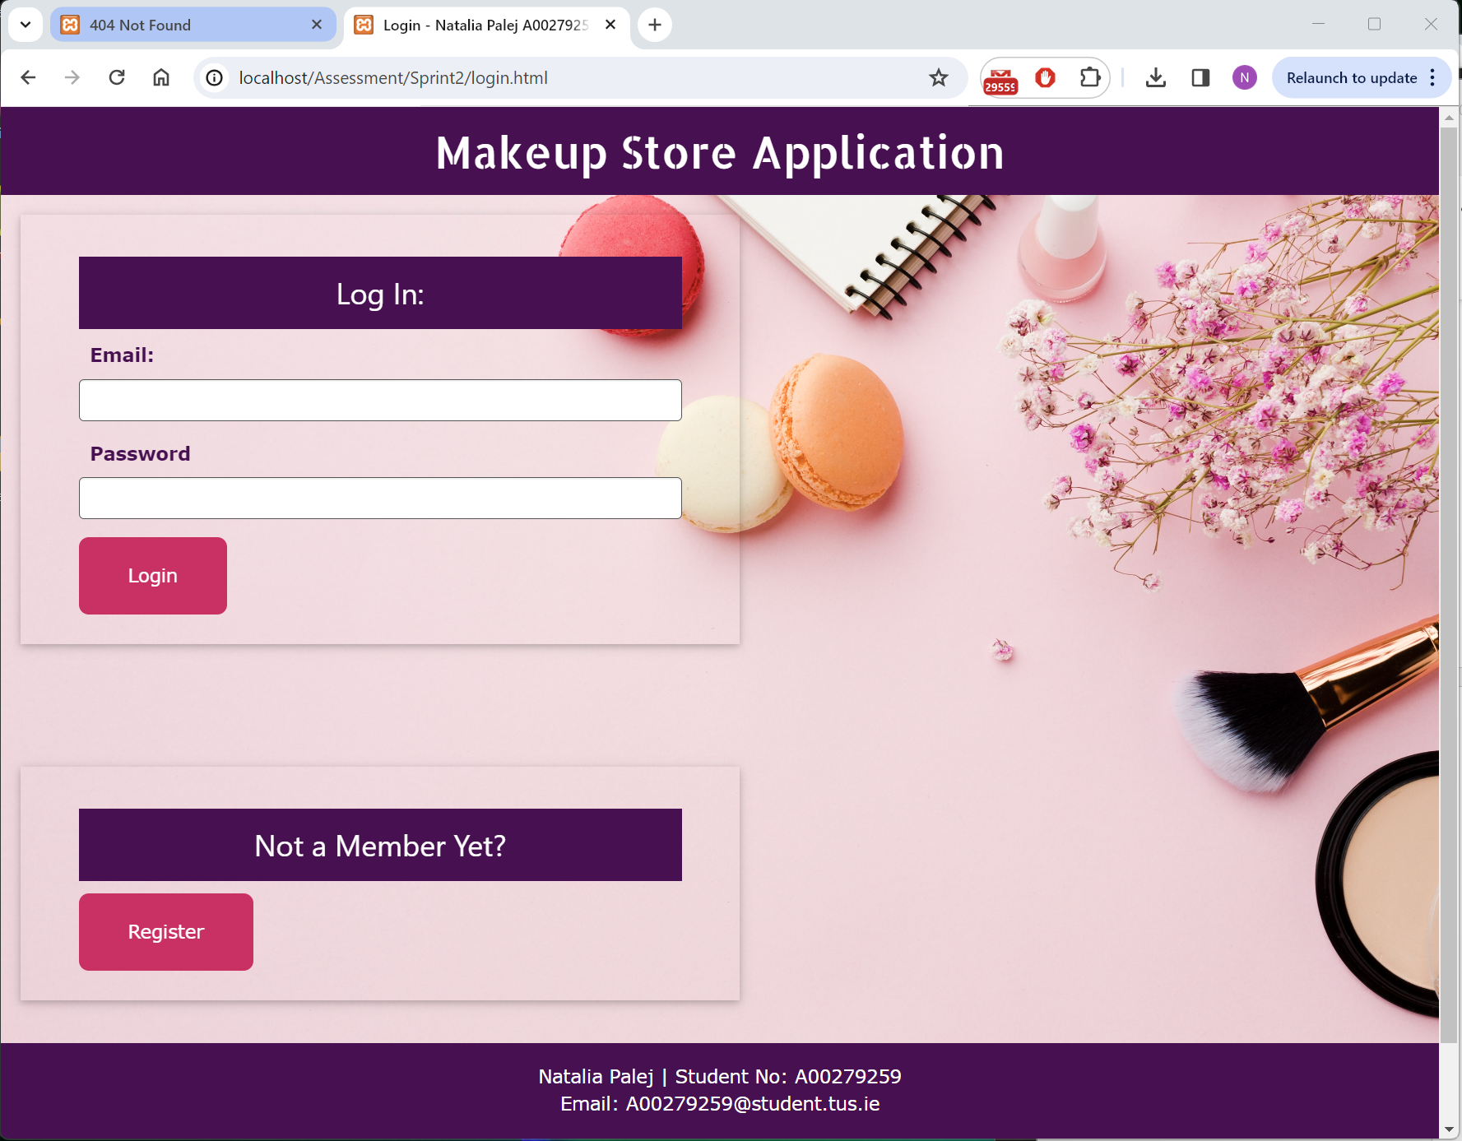

#### Test #2

|  |  |
| --- | --- |
| User Story | Get server connection |
| Test Case ID | #2 |
| Description | Verify invalid URL |
| When | Enter invalid URL: <http://localhost/login.html> |
| Then | Error 404 “Not Found” |
| Test Result | Passed Failed |

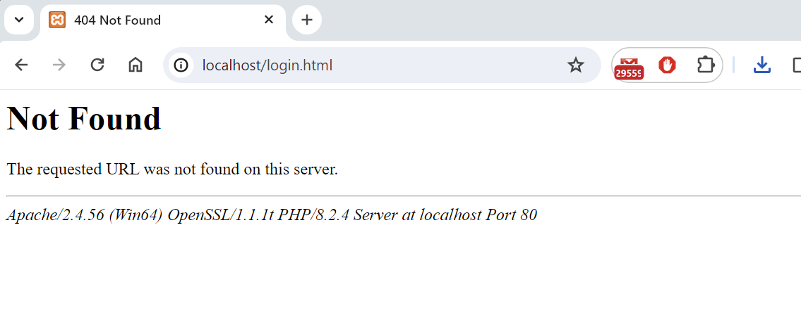

#### Test #3

|  |  |
| --- | --- |
| User Story | Add products to the database |
| Test Case ID | #3 |
| Description | Verify new product can be added |
| When | <http://localhost/Assessment/Sprint2/admin.html> Add Tab  Product Name: CHARLOTTE TILBURY BEAUTY LIGHT WAND  Category: face  Description: This dreamy highlighter flatters all skin tones and is brimming with treated pearls to give a luminous, soft-focus finish. Free from giveaway glitter or sparkle, this believable radiance potion is perfectly applied using the soft cushion applicator pad, which delivers and blends product evenly.  Company: Charlotte Tilbury  Price: 33.90 Stock: 180 Sale: No  Discontinued: No Picture: charlotte-contour-wand.png |
| Then | Alert “success : addProduct() Product <name> added successfully” |
| Test Result | Passed Failed |

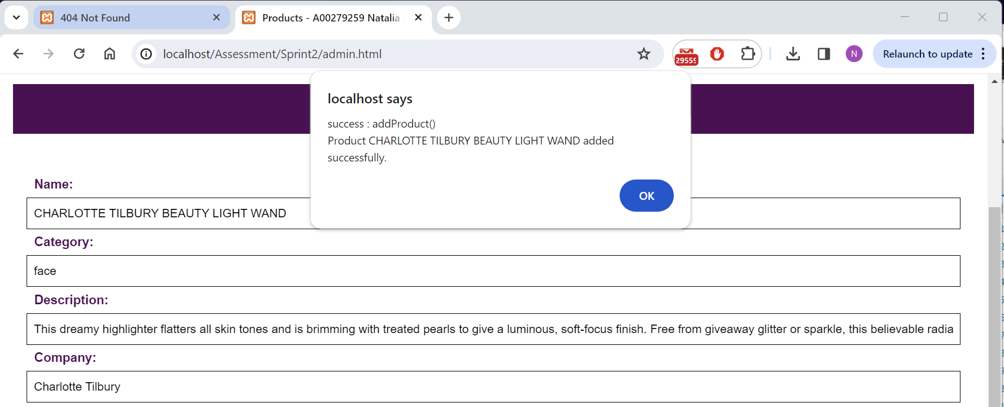

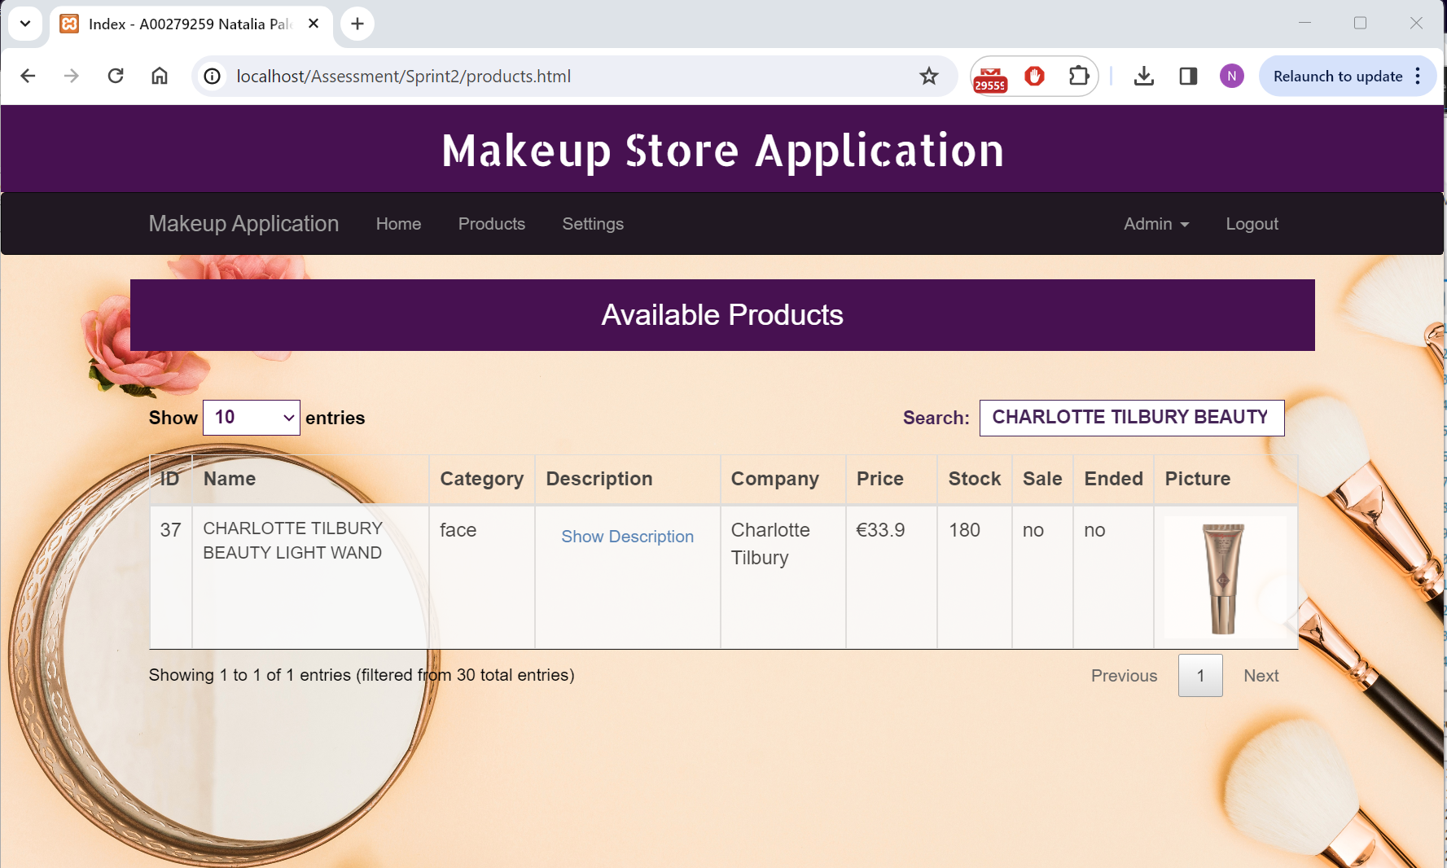

#### Test #4

|  |  |
| --- | --- |
| User Story | Update product details in database based on its ID |
| Test Case ID | #4 |
| Description | Verify product was successfully updated |
| When | <http://localhost/Assessment/Sprint2/admin.html> Update Tab  ProductID = 37  Update to price = 24.50, sale = yes |
| Then | Alert “success : Product updated <productID> <productName> |
| Test Result | Passed Failed |

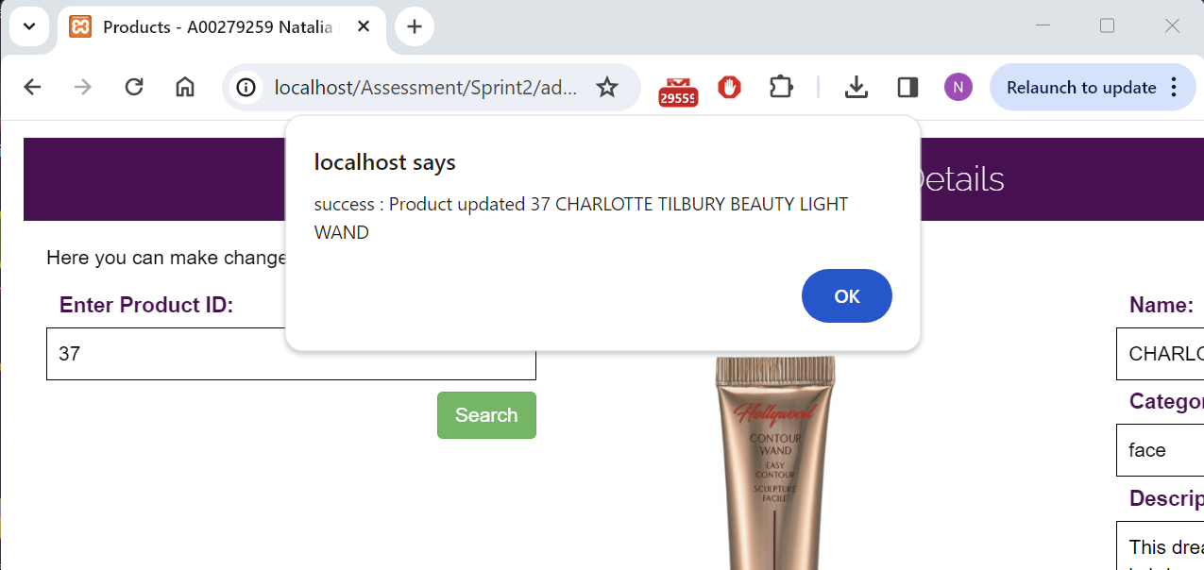

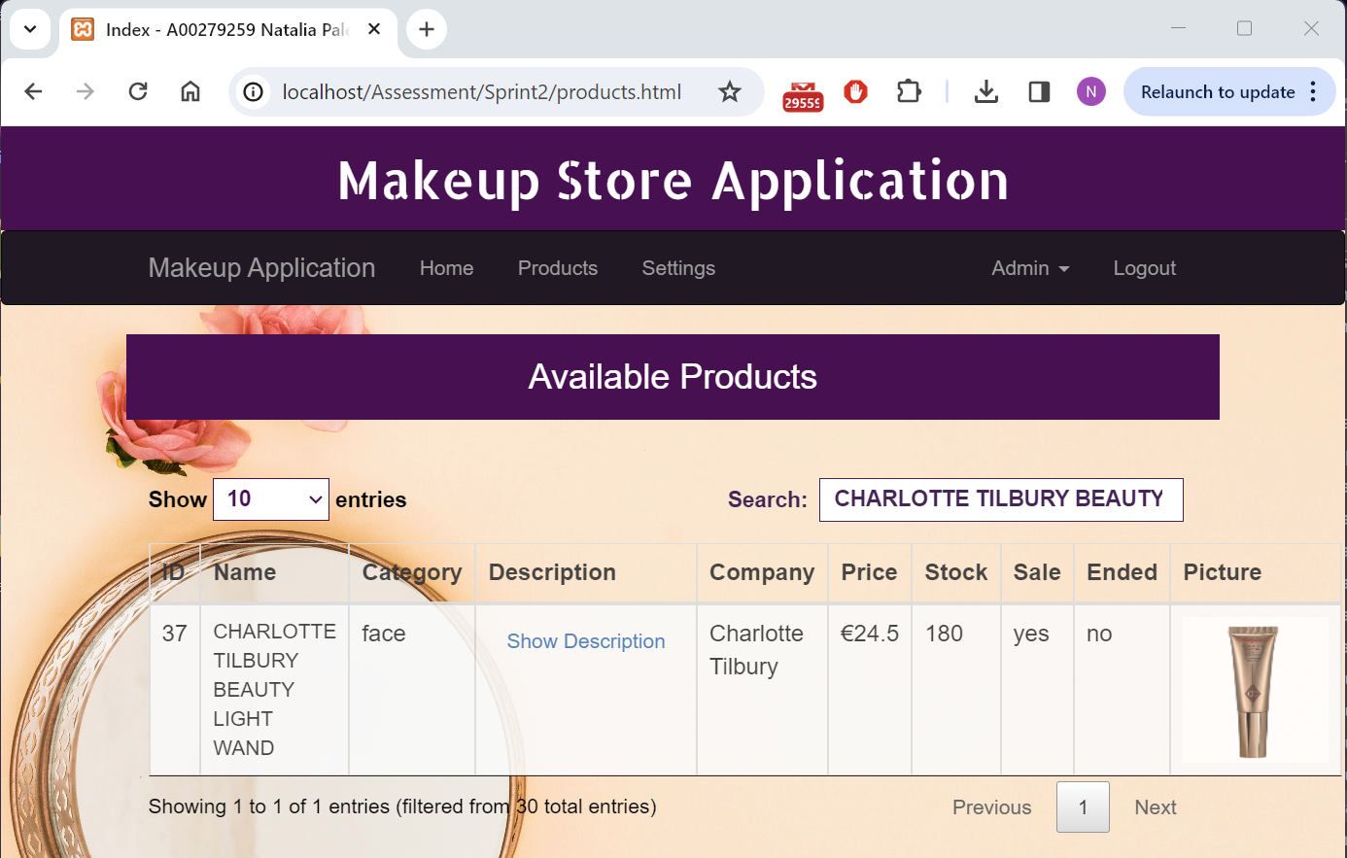

#### Test #5

|  |  |
| --- | --- |
| User Story | Delete product from the database based on its ID |
| Test Case ID | #5 |
| Description | Verify product was successfully deleted |
| When | <http://localhost/Assessment/Sprint2/admin.html> Delete Tab  ProductID = 37 |
| Then | Alert “success : product <productID> deleted. You will be directed to Admin page” |
| Test Result | Passed Failed |

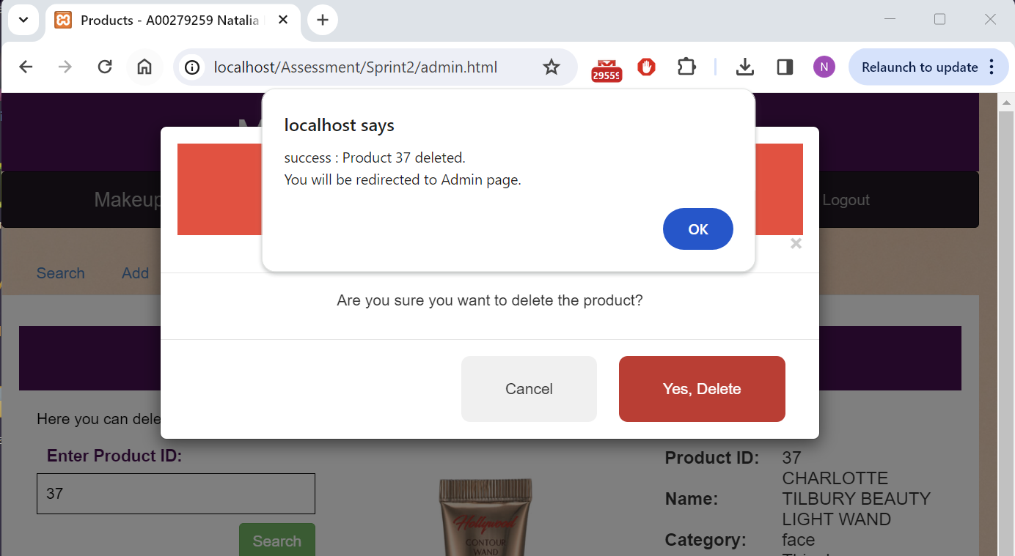

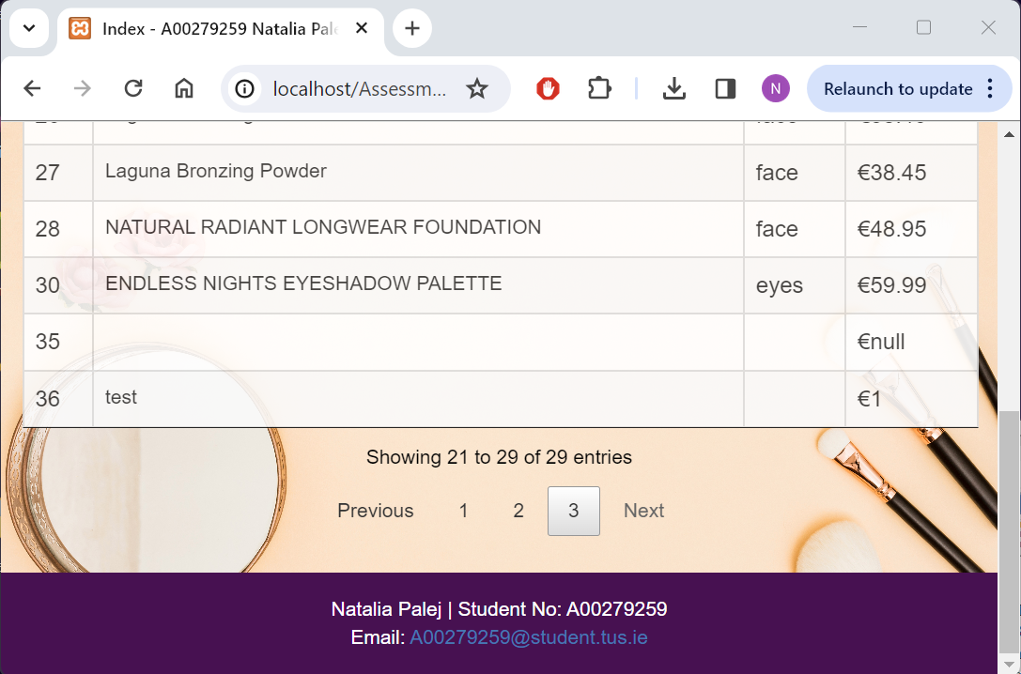

### User Test Cases

#### Test #1

|  |  |
| --- | --- |
| User Story | Log in to the application |
| Test Case ID | #1 |
| Description | Verify user can log in with valid credentials |
| When | Valid credentials entered:  Email: Test Password: Test |
| Then | User is redirected to index.html page |
| Test Result | Passed Failed |

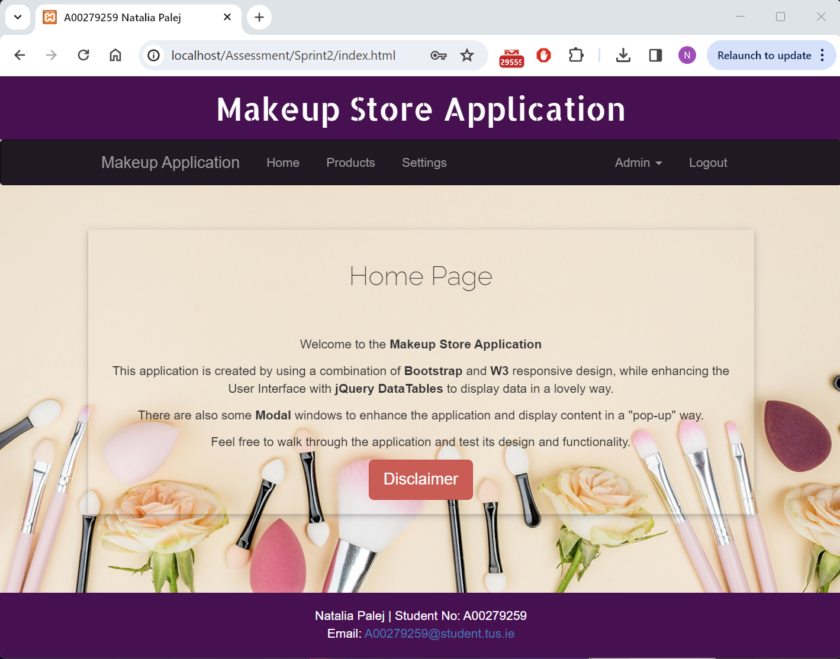

#### Test #2

|  |  |
| --- | --- |
| User Story | Log in to the application |
| Test Case ID | #2 |
| Description | Verify error thrown when invalid credentials are entered |
| When | Invalid credentials entered  Email: Teest Password: Test |
| Then | Alert “error : Invalid email or password. Please try again.” |
| Test Result | Passed Failed |

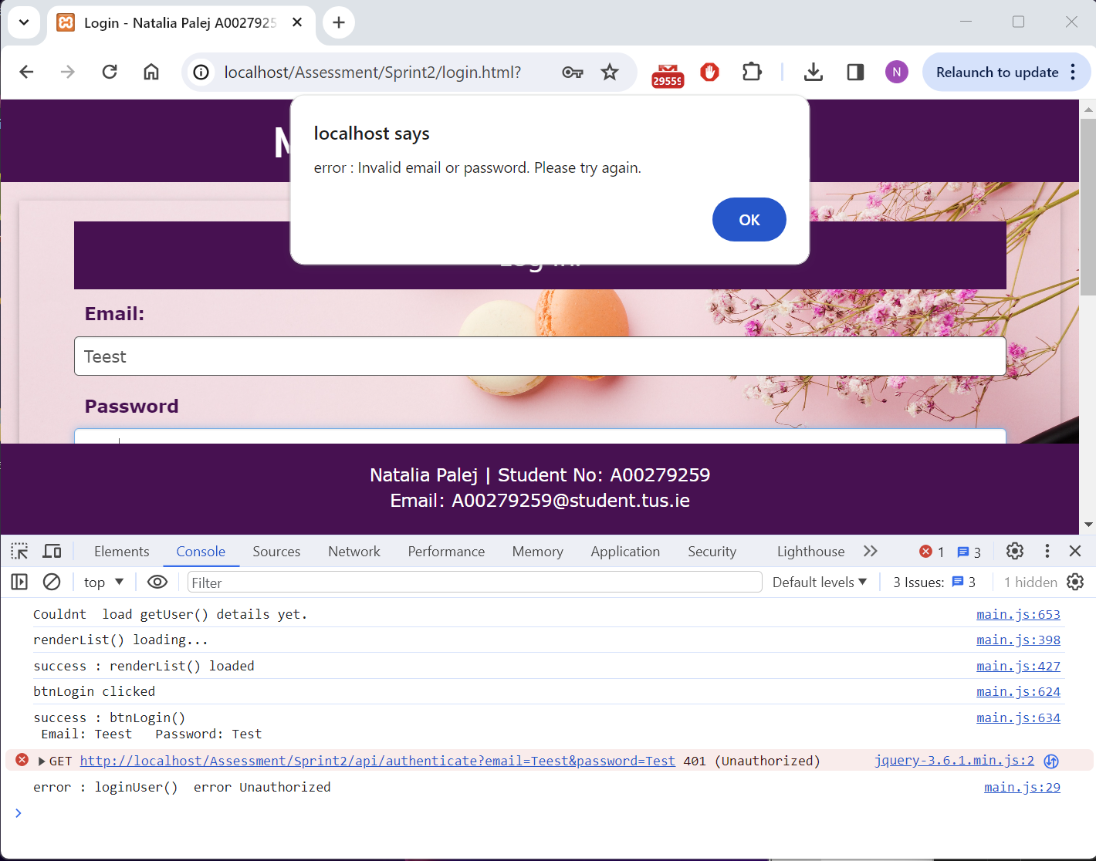

#### Test #3

|  |  |
| --- | --- |
| User Story | Log out from the application |
| Test Case ID | #3 |
| Description | Verify user can successfully log out and session is closed |
| When | Logout button and confirmation buttons is clicked. |
| Then | User is redirected to logout.html |
| Test Result | Passed Failed |

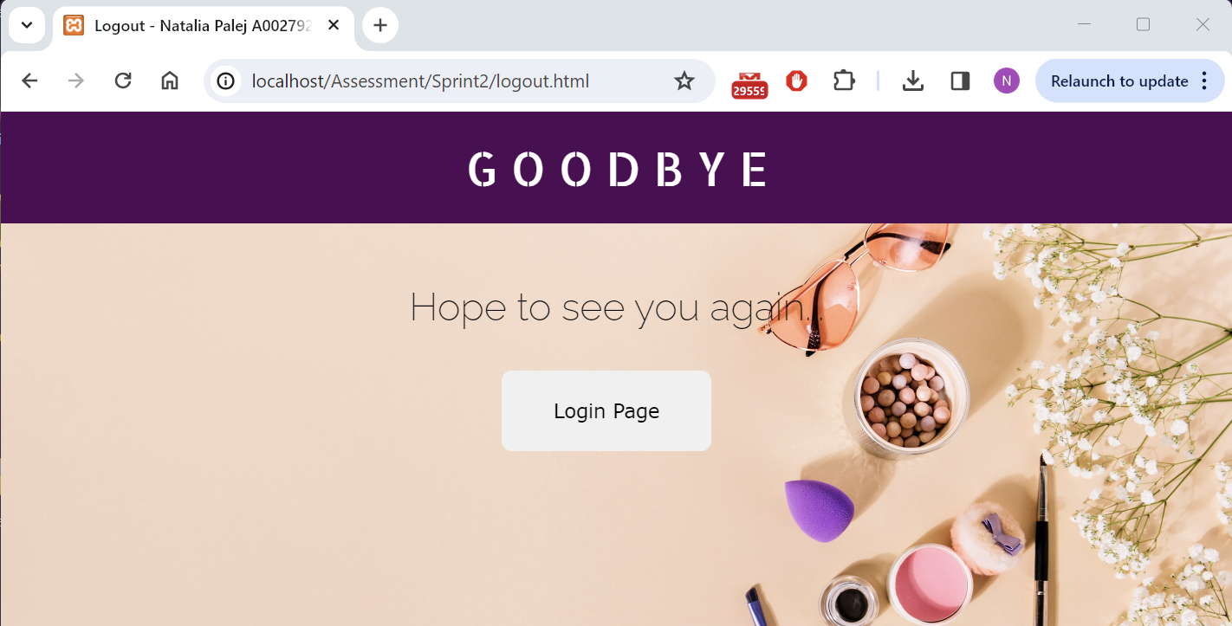

#### Test #4

|  |  |
| --- | --- |
| User Story | Register to the application |
| Test Case ID | #4 |
| Description | Verify new user is added to database |
| When | <http://localhost/Assessment/Sprint2/register.html>  Name: Test  Last Name: Test  Username: Test  Email: Test  Password: Test  Address: Test  Phone No: Test  Picture: avatar.png |
| Then | Alert “success : addUser() User <firstName> <lastName> added successfully. |
| Test Result | Passed Failed |

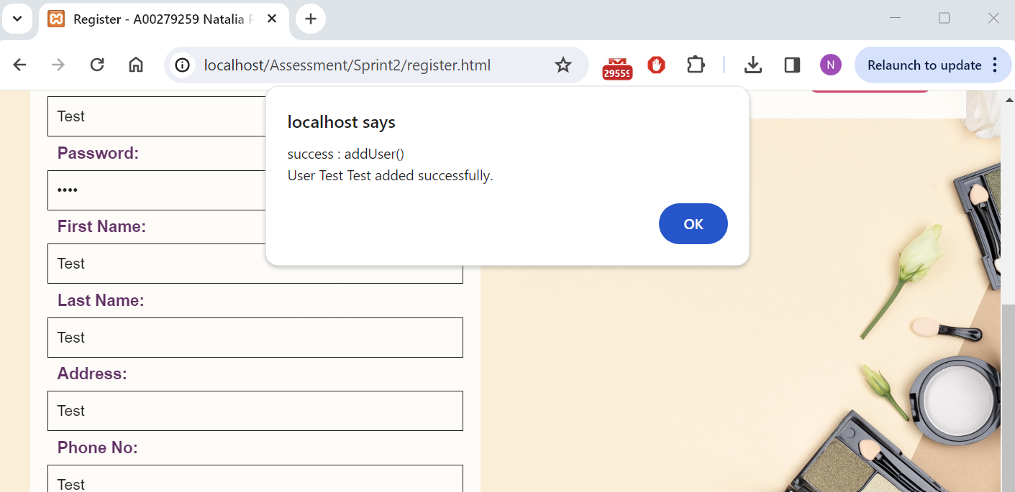

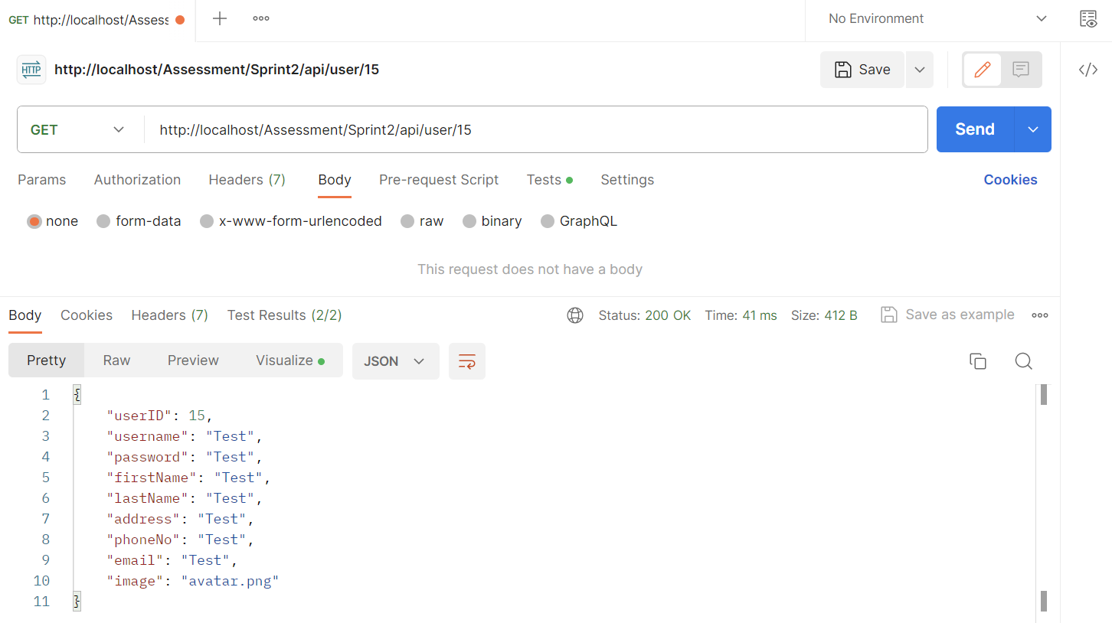

#### Test #5

|  |  |
| --- | --- |
| User Story | Search through products dynamically |
| Test Case ID | #5 |
| Description | Verify user can search through products using bootstrap dataTable |
| When | http://localhost/Assessment/Sprint2/products.html  Search: agi |
| Then | Products that contain “agi” in any field will appear |
| Test Result | Passed Failed |

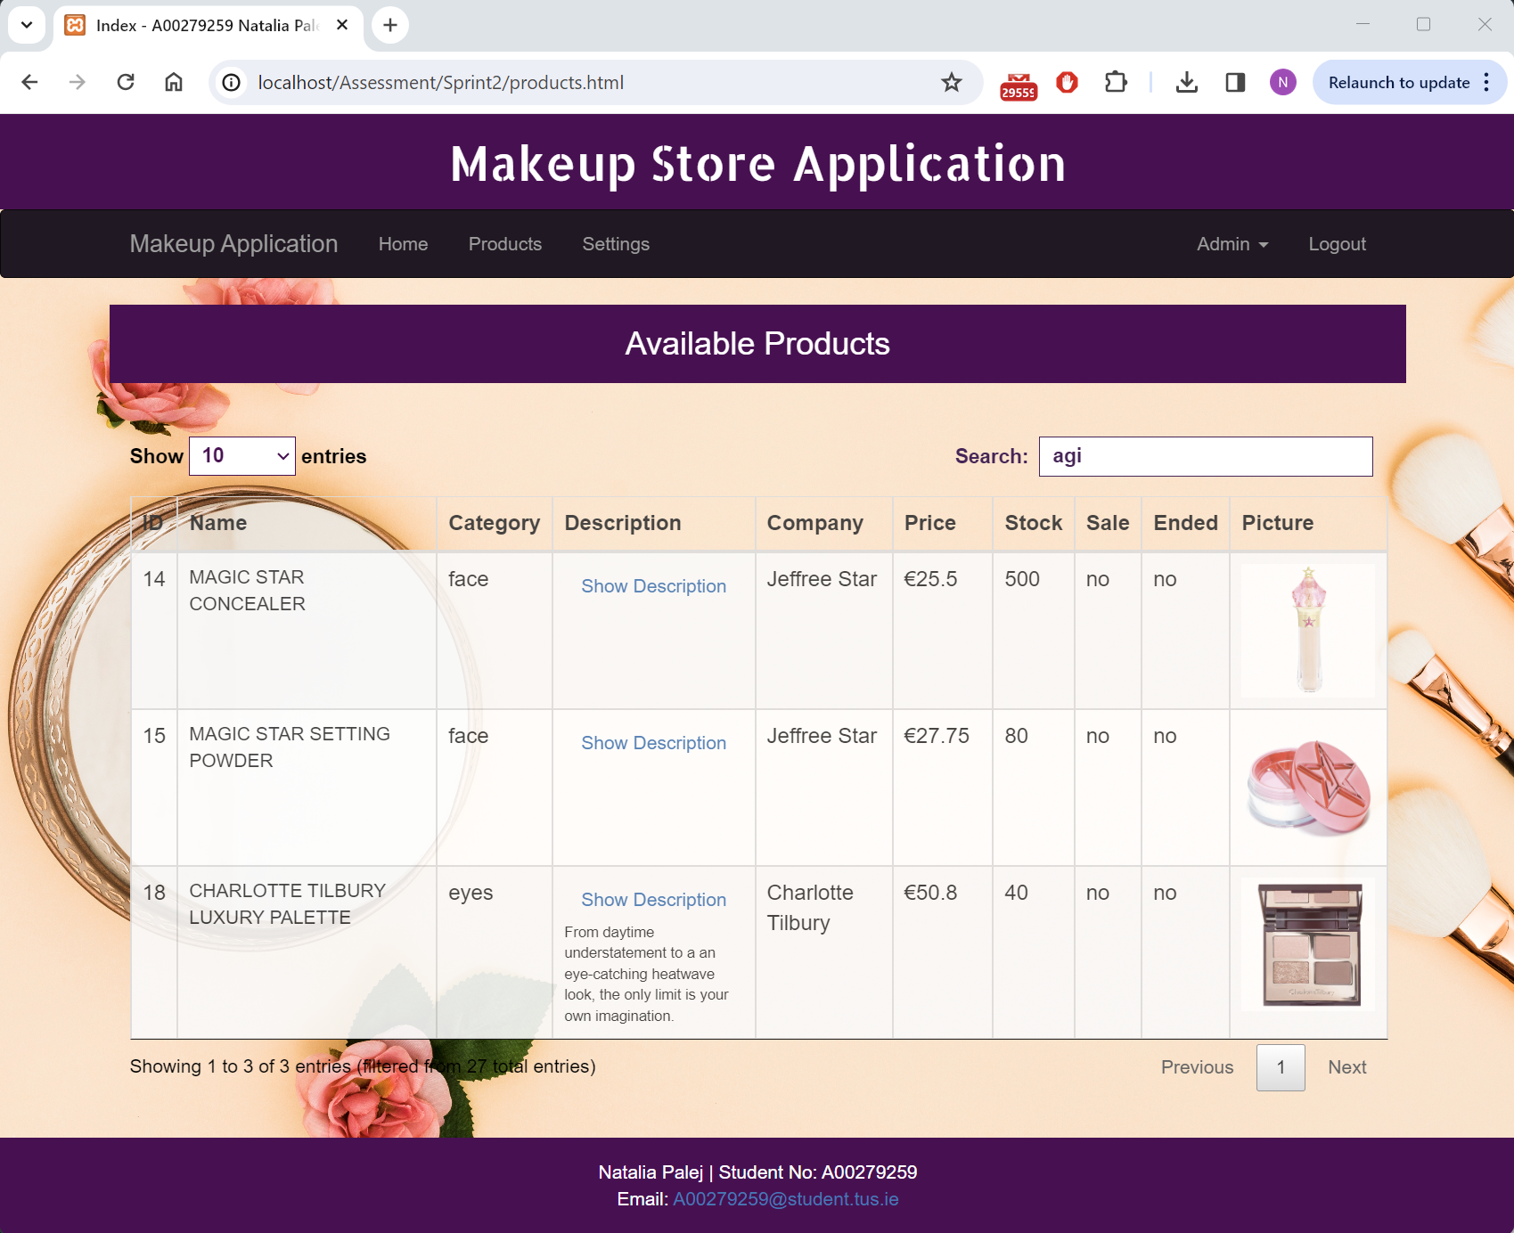

#### Test #6

|  |  |
| --- | --- |
| User Story | Search for product by its name |
| Test Case ID | #6 |
| Description | Verify user can search for product by its name |
| When | <http://localhost/Assessment/Sprint2/admin.html> Search Tab  Enter Product Name: Magic |
| Then | Product will appear beside the search field |
| Test Result | Passed Failed |

Before:

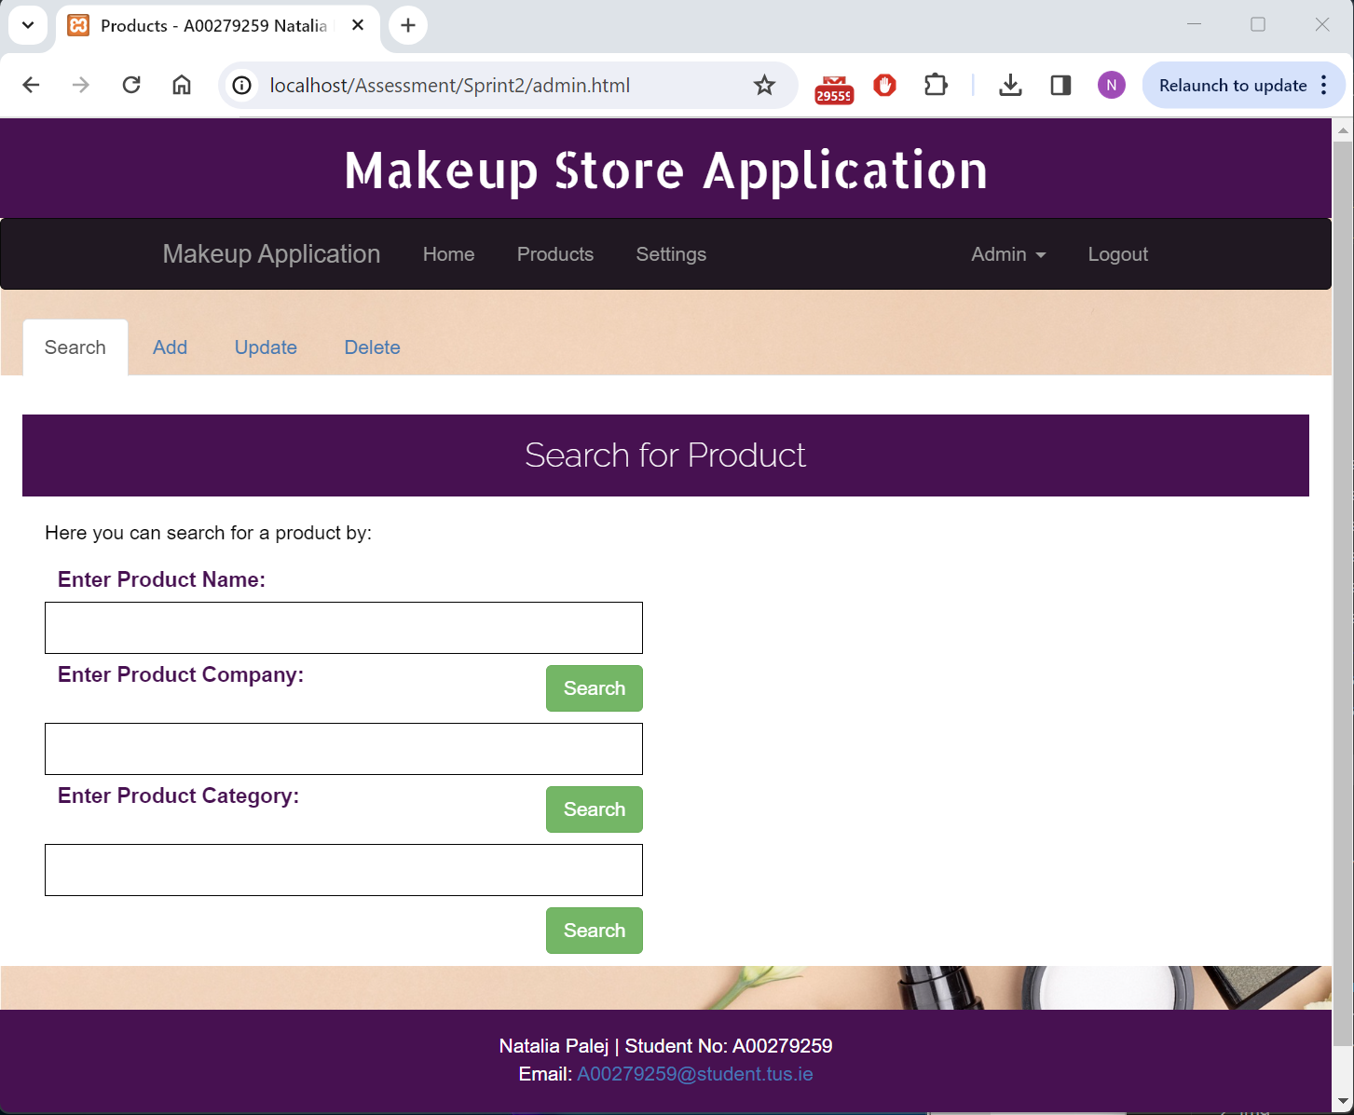

After:

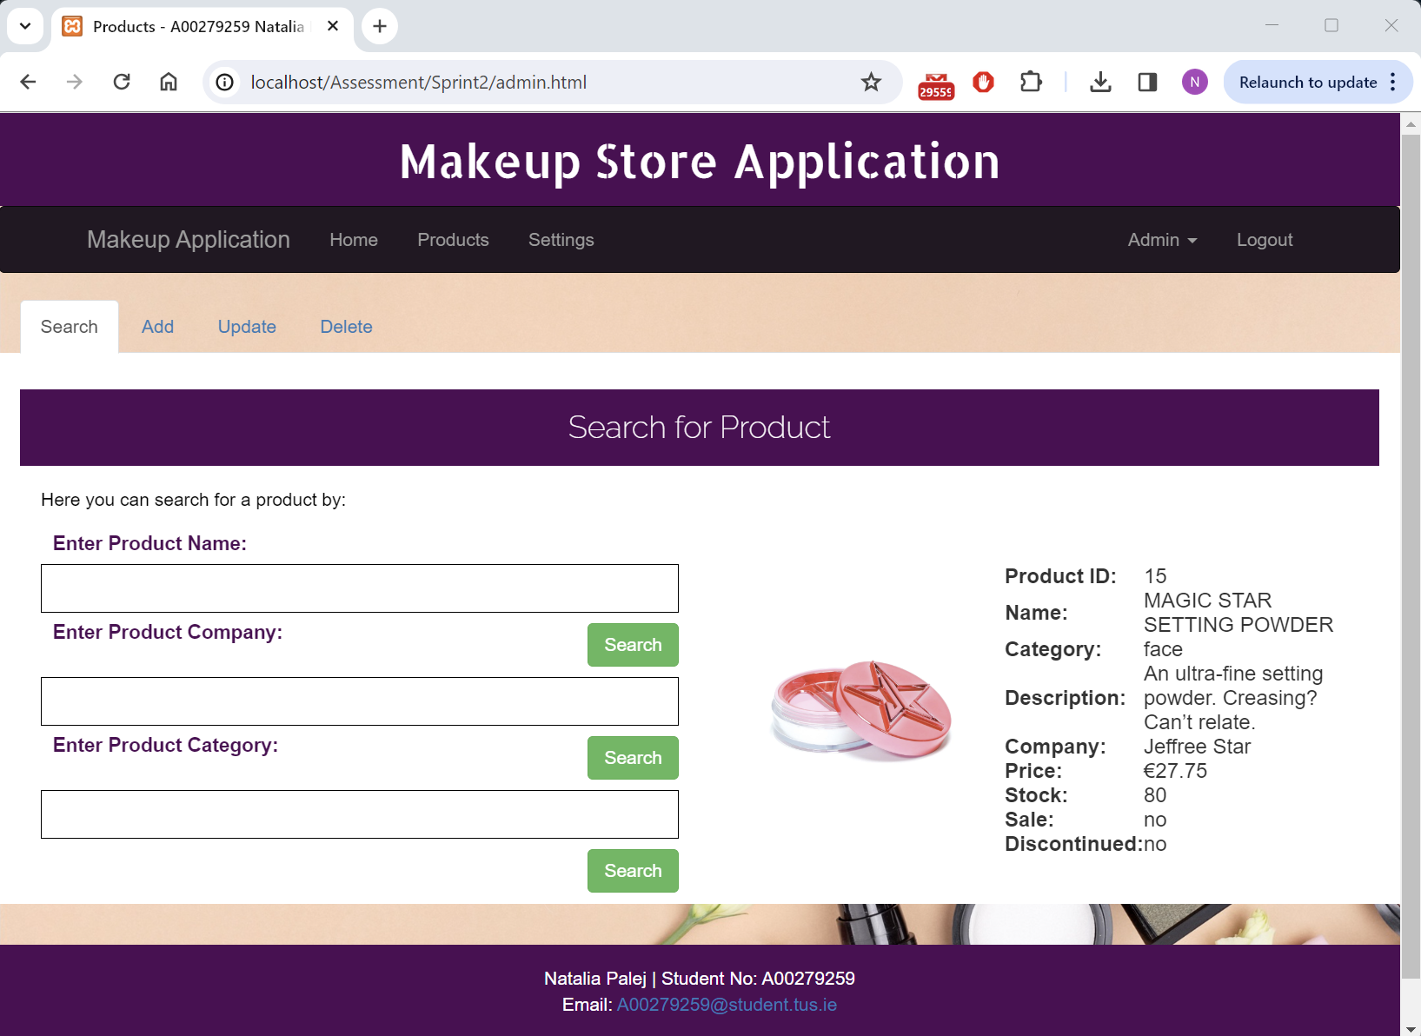

#### Test #7

|  |  |
| --- | --- |
| User Story | Search for product by its company name |
| Test Case ID | #7 |
| Description | Verify user can search for products by company name |
| When | <http://localhost/Assessment/Sprint2/admin.html> Search Tab  Enter Product Company: Benefit |
| Then | All Benefit products will appear below the search tabs |
| Test Result | Passed Failed |

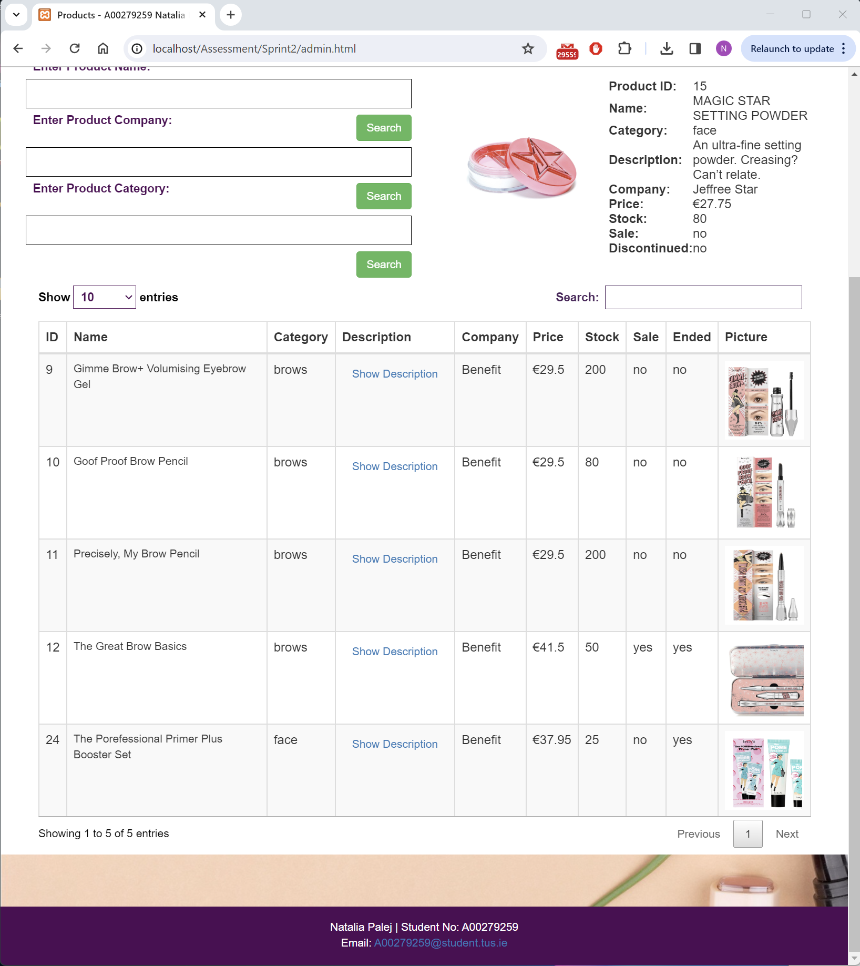

#### Test #8

|  |  |
| --- | --- |
| User Story | Search for product by its category |
| Test Case ID | #8 |
| Description | Verify user can search for products based on the category |
| When | <http://localhost/Assessment/Sprint2/admin.html> Search Tab  Enter Product Category: lips |
| Then | All lips products will appear below the search fields |
| Test Result | Passed Failed |

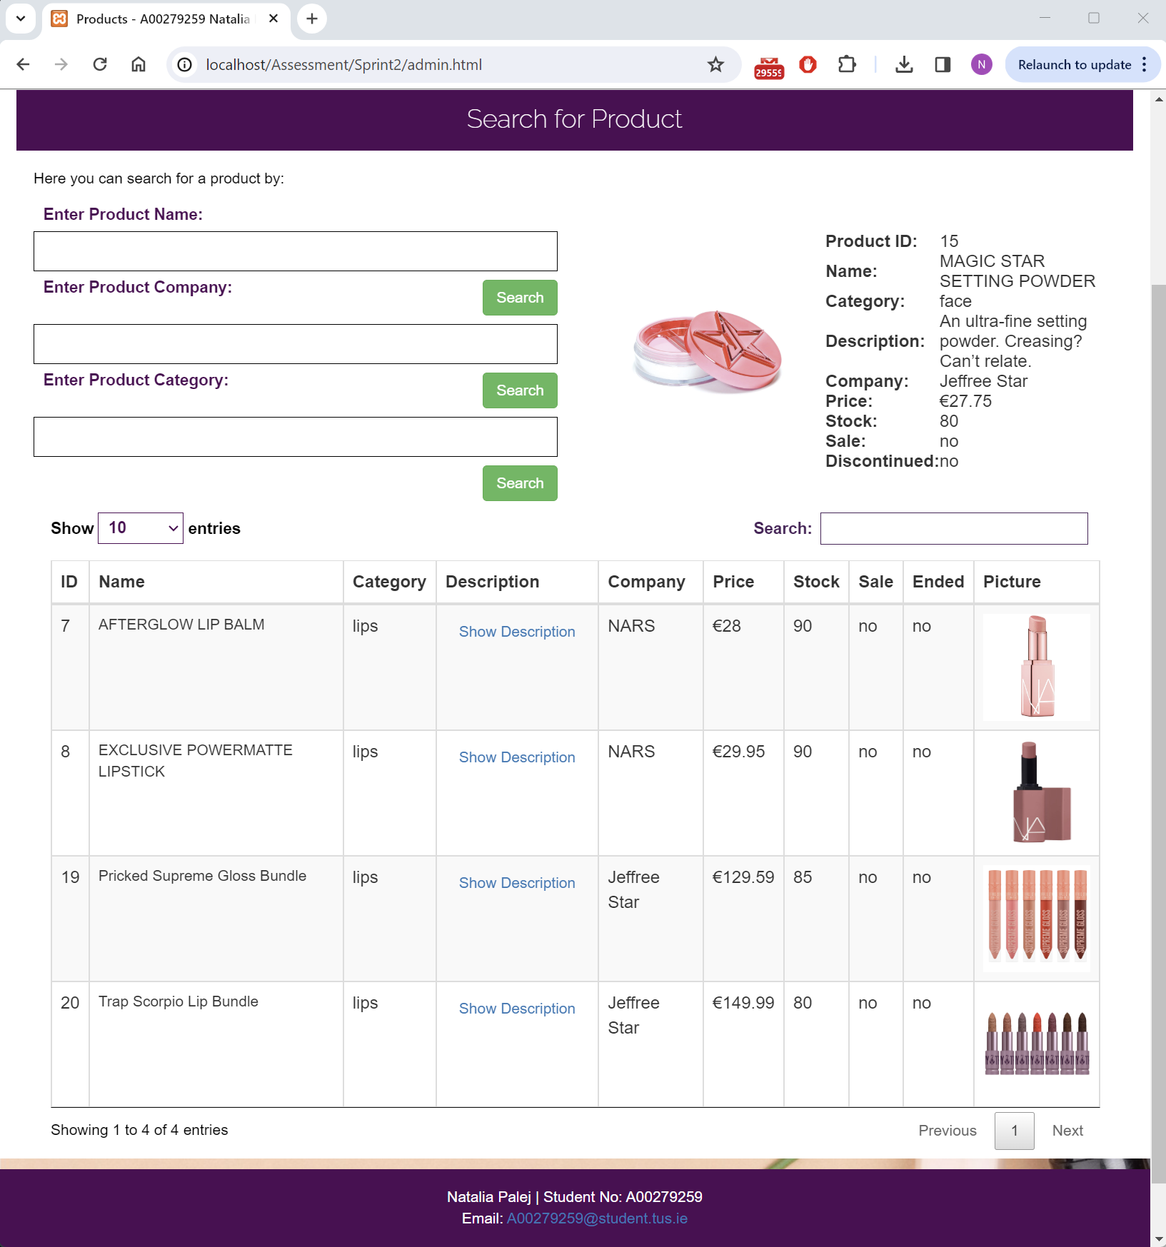

#### Test #9

|  |  |
| --- | --- |
| User Story | Update user details |
| Test Case ID | #9 |
| Description | Verify user can update their details |
| When | <http://localhost/Assessment/Sprint2/settings.html> Update Tab  Update First Name: Natalia Email: [natalia@gmail.com](mailto:natalia@gmail.com) Username: Nat  Picture: avatar.jpg |
| Then | Alert “success: updatUser() User <userID> <firstName> updated successfully” |
| Test Result | Passed Failed |

Before:

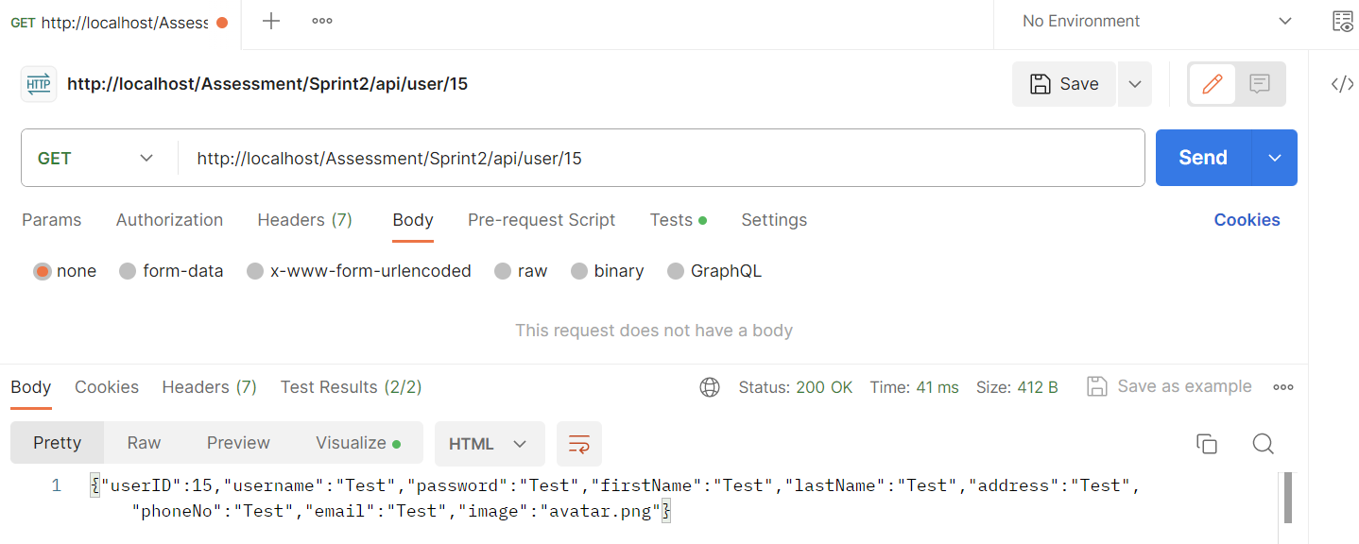

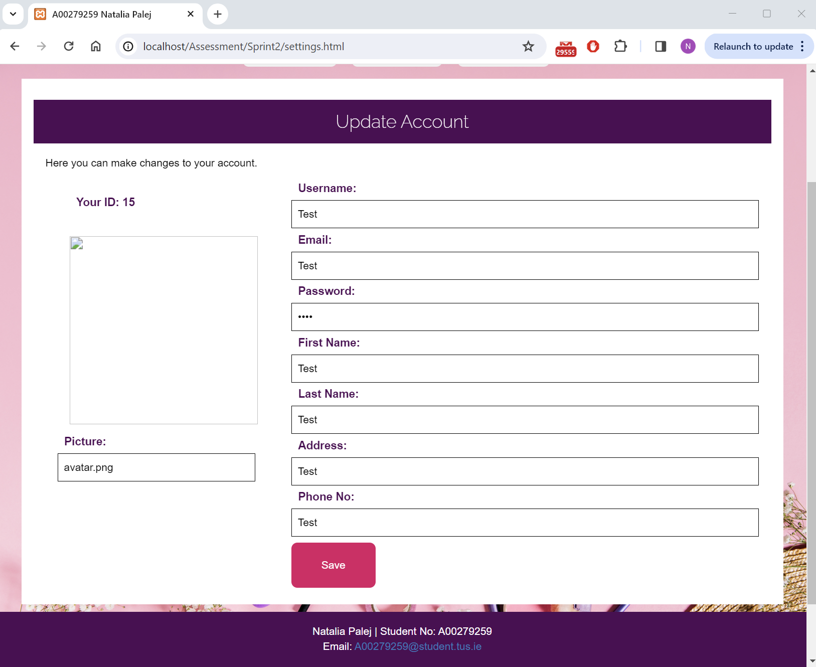

After:

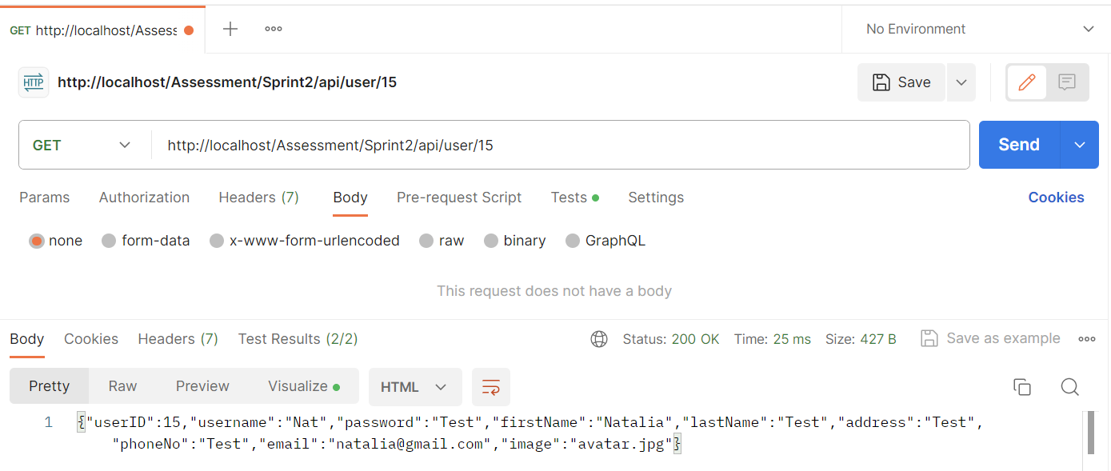

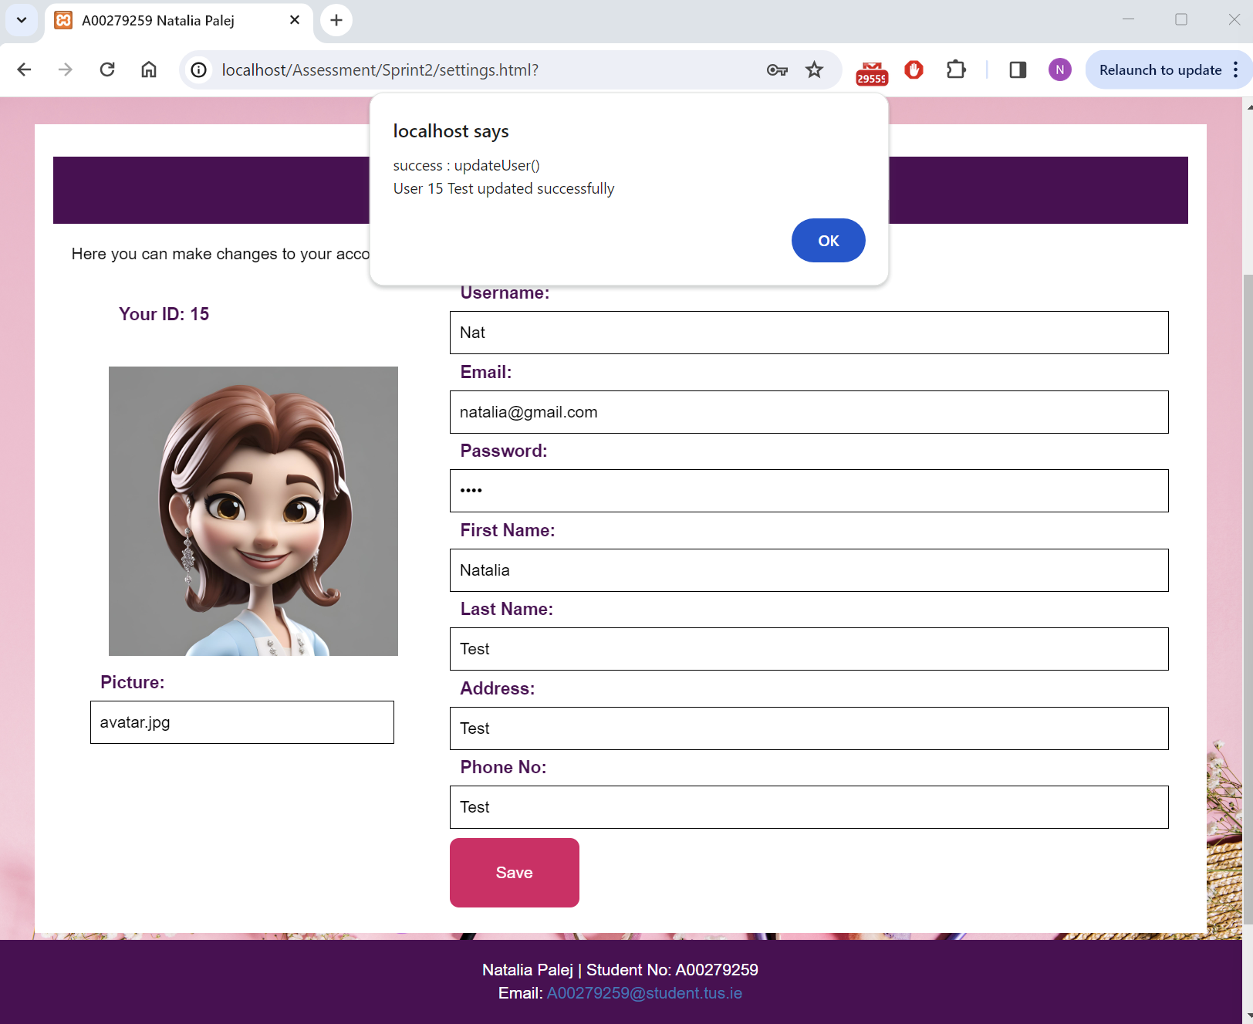

#### Test #10

|  |  |
| --- | --- |
| User Story | Delete user account |
| Test Case ID | #10 |
| Description | Verify user can delete their account |
| When | <http://localhost/Assessment/Sprint2/settings.html>? Delete Tab  Delete button and confirmation clicked. |
| Then | Alert “success : deleteUser() User <userID> <firstName*> was deleted. You will be redirected to login page now. |
| Test Result | Passed Failed |

*since I do not set new session details for logged in user after updating, “Test” appears as initially that was my “name” field.

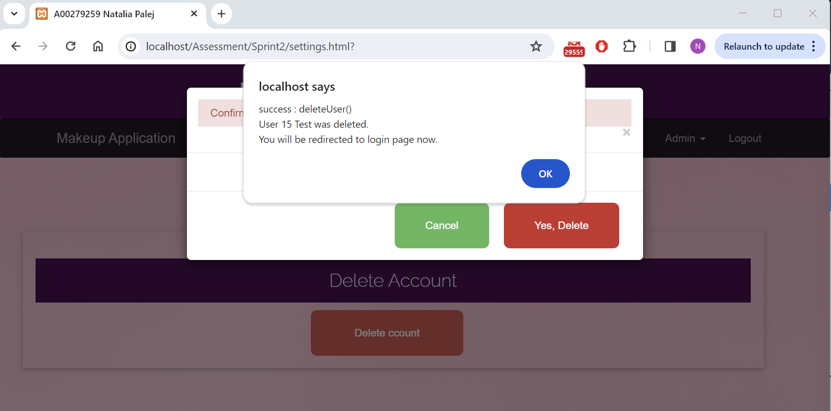

Postman Verification:

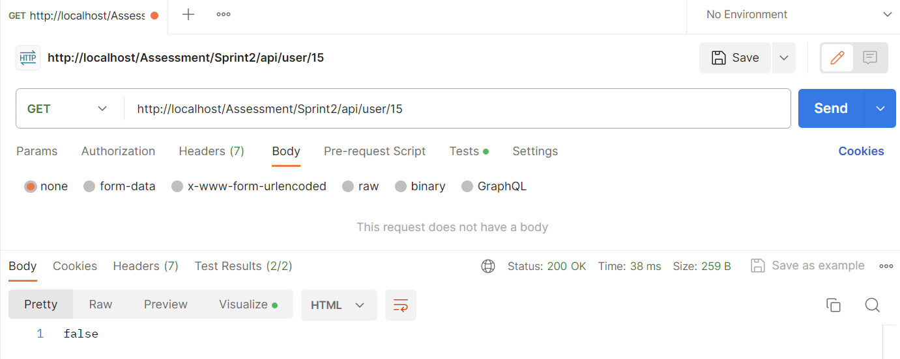

Login Verification: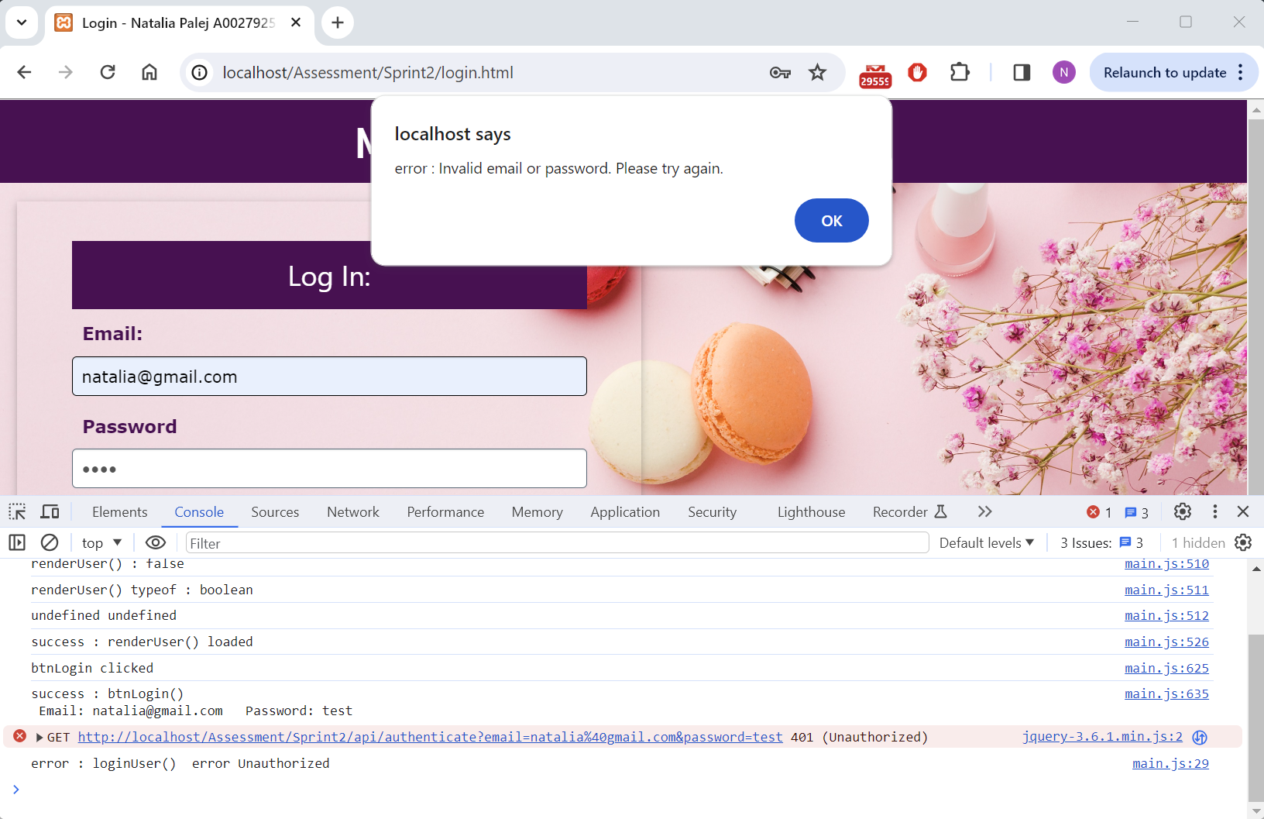

### Test Report

|  |  |  |  |  |
| --- | --- | --- | --- | --- |
| **Test Type** | **Database** | **Total Tests** | **Number Passed** | **Number Failed** |
| Manual | CEO | 5 | 5 | N/A |
| User | 10 | 10 | N/A |

### Bugs Report

#### Bug #1 N/A

|  |
| --- |
| Bug Description |
| N/A |
| Resolution |
| N/A |

## References

1. Used w3schools for:
   1. W3 CSS <https://www.w3schools.com/w3css/default.asp>
   2. CSS <https://www.w3schools.com/css/default.asp>
   3. Back Button Method
      1. <https://www.w3schools.com/jsref/obj_location.asp>
      2. <https://www.w3schools.com/jsref/met_his_back.asp>
   4. Bootstrap <https://www.w3schools.com/bootstrap/bootstrap_ver.asp>
2. Fonts Taken From: <https://fonts.google.com/specimen/Edu+TAS+Beginner>
3. Background Images and Avatars downloaded from:
   1. <https://www.freepik.com/>
4. Product Images and Details taken from:
   1. <https://www.cultbeauty.com/>
   2. <https://www.beautybay.com/>

## Screencast Link

[NPalej_A00279259 Screencast.mp4](https://tusmm-my.sharepoint.com/:v:/g/personal/a00279259_student_tus_ie/EWCNxoBIL6BNqMnxKefjWaYB-7VGqbdu8mcWSKEboCesOQ?e=HRX2n8&nav=eyJyZWZlcnJhbEluZm8iOnsicmVmZXJyYWxBcHAiOiJTdHJlYW1XZWJBcHAiLCJyZWZlcnJhbFZpZXciOiJTaGFyZURpYWxvZy1MaW5rIiwicmVmZXJyYWxBcHBQbGF0Zm9ybSI6IldlYiIsInJlZmVycmFsTW9kZSI6InZpZXcifX0%3D)

or

<https://tusmm-my.sharepoint.com/personal/a00279259_student_tus_ie/_layouts/15/stream.aspx?id=%2Fpersonal%2Fa00279259%5Fstudent%5Ftus%5Fie%2FDocuments%2FYear3%2FWeb%20Screencast%2FSprint%20%232%2FNPalej%5FA00279259%20Screencast%2Emp4&referrer=StreamWebApp%2EWeb&referrerScenario=AddressBarCopied%2Eview>